1. DimAccount

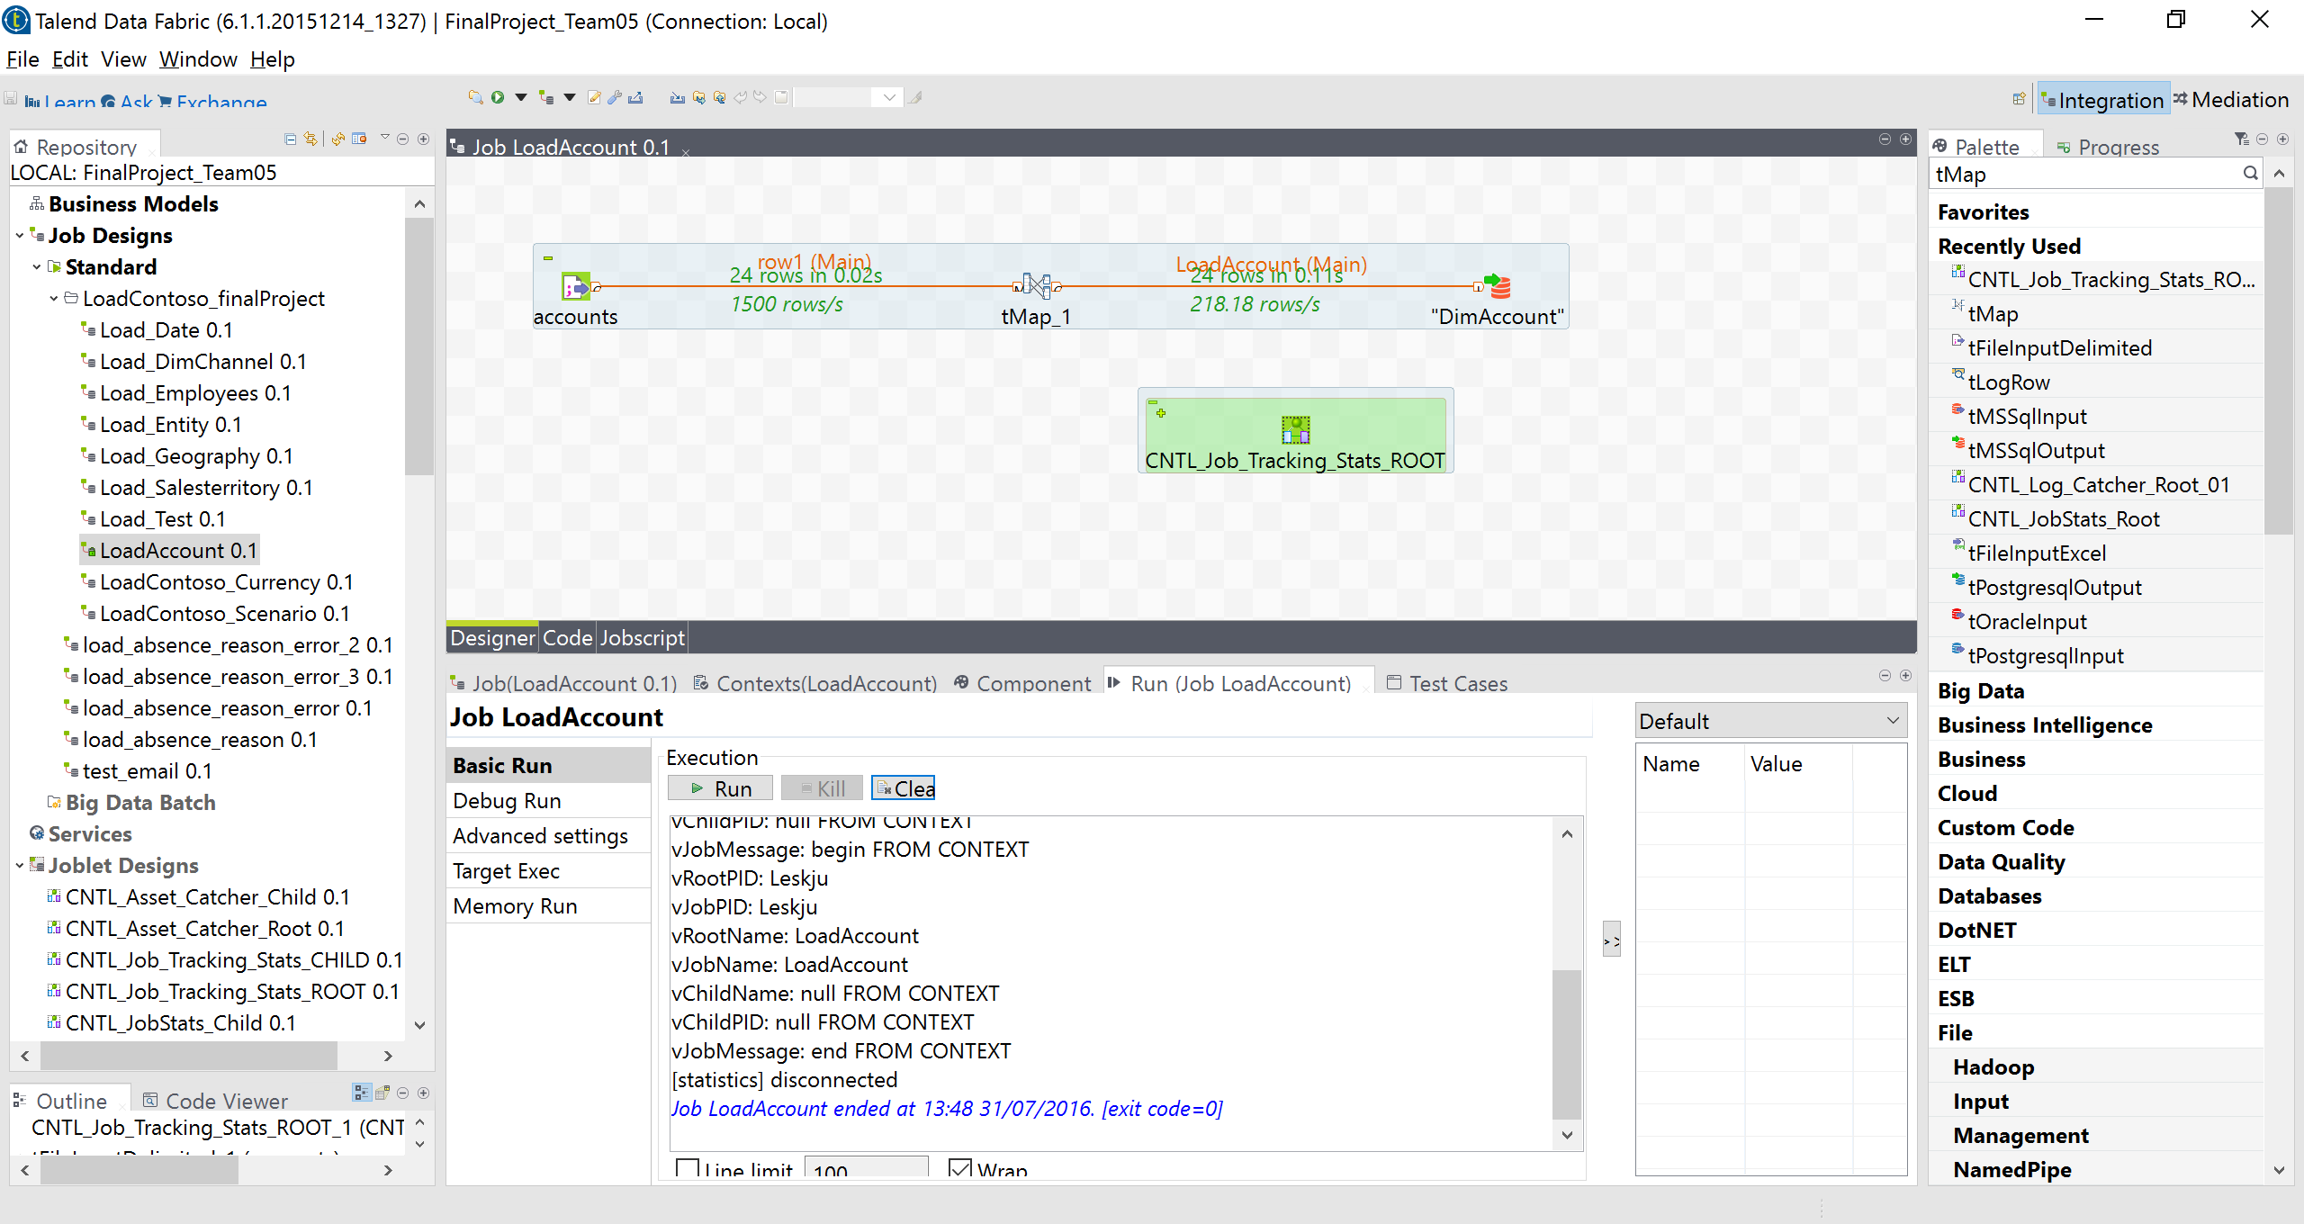

1. DimGeography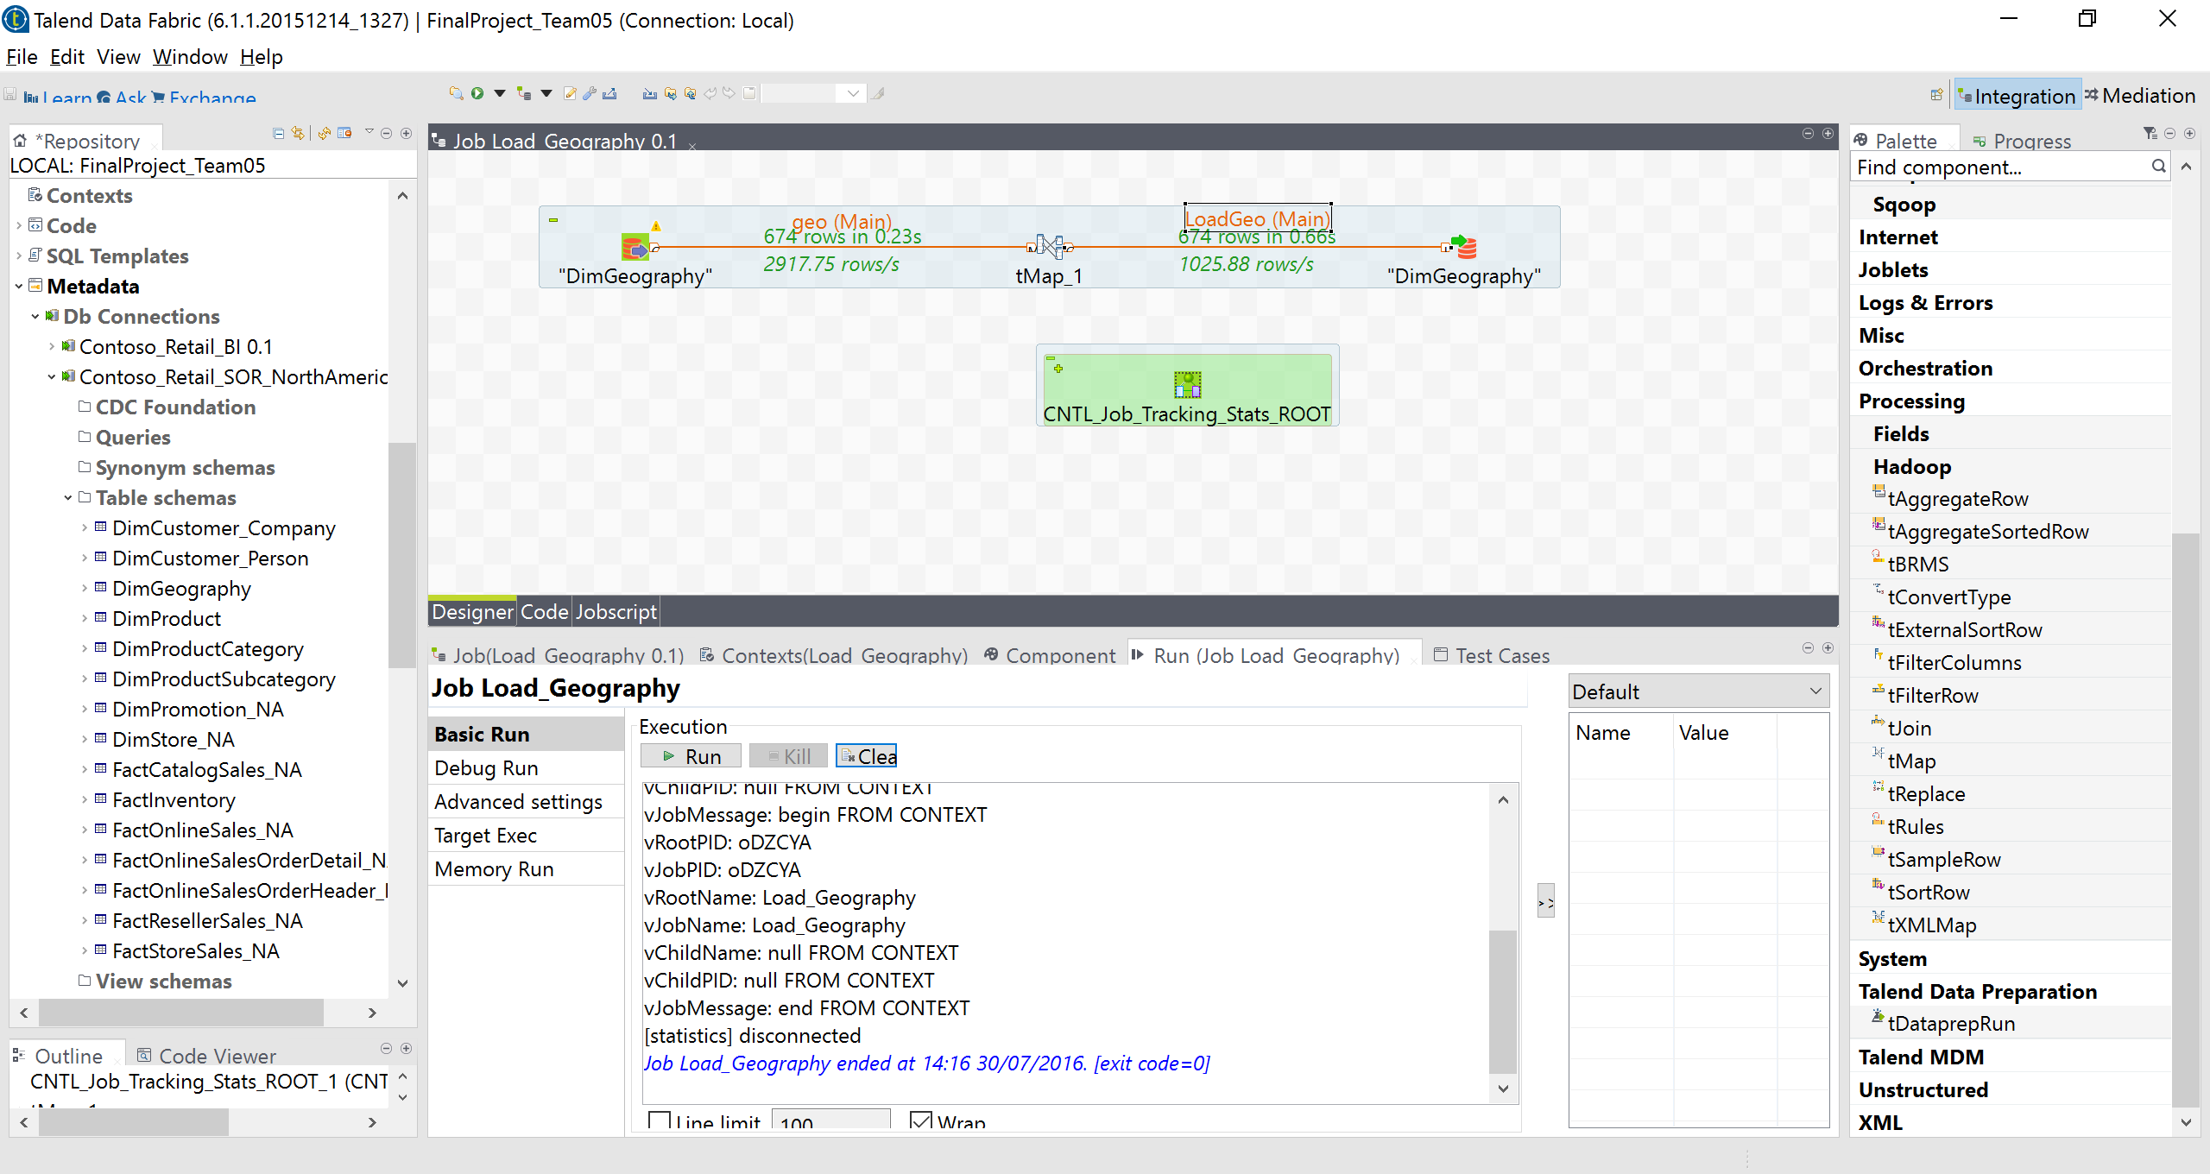
2. DimChannel

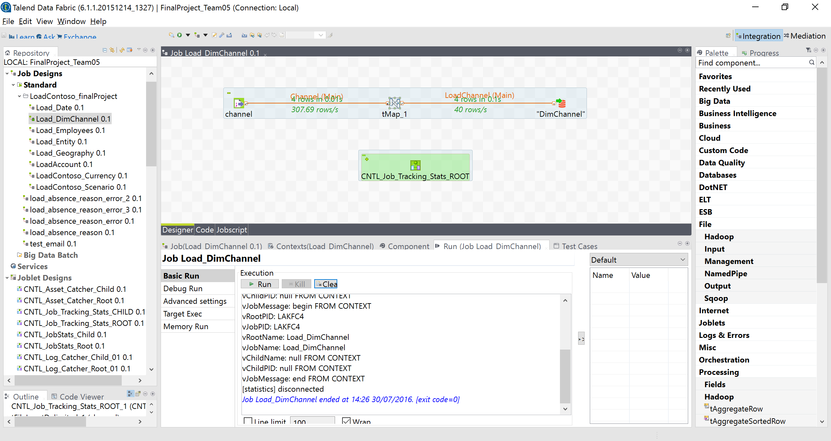

1. DimCurrency

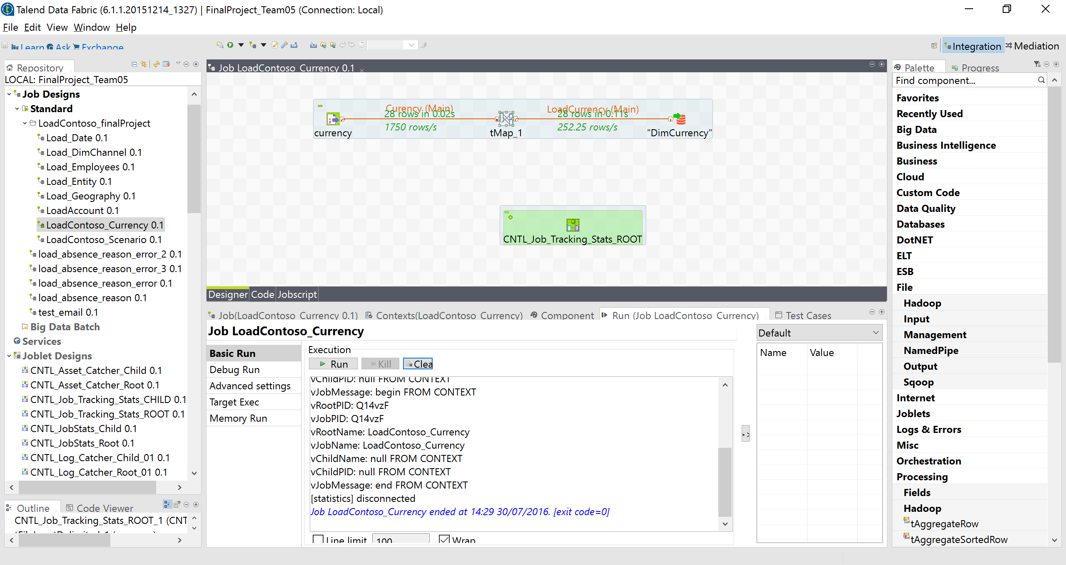

1. DimEmployee

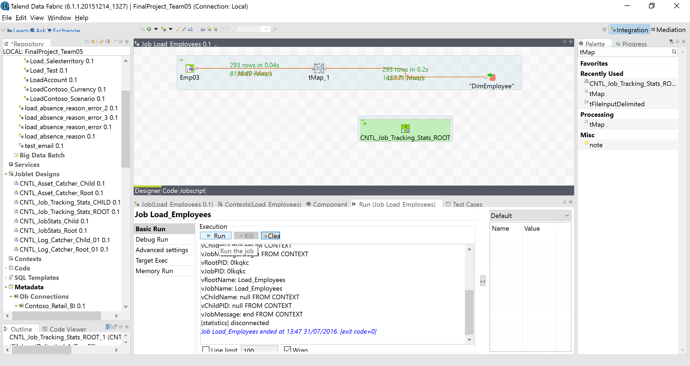

1. DimDate

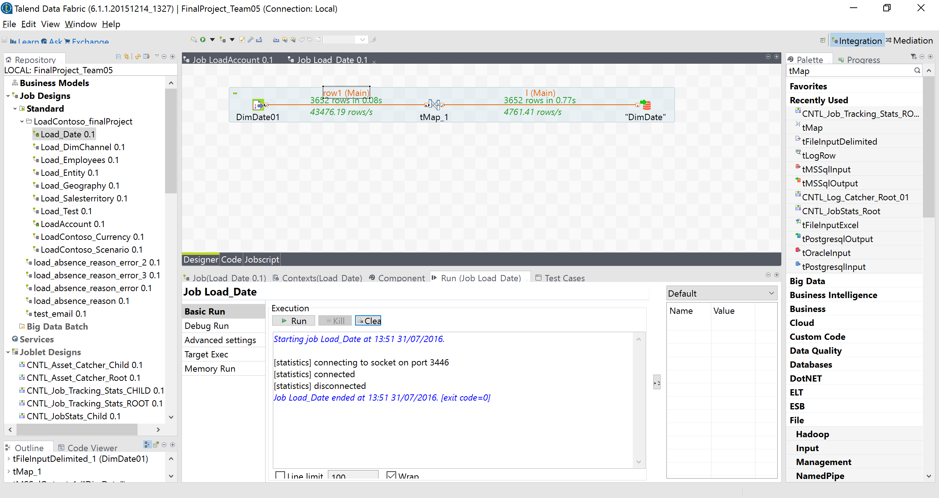

1. DimProduct

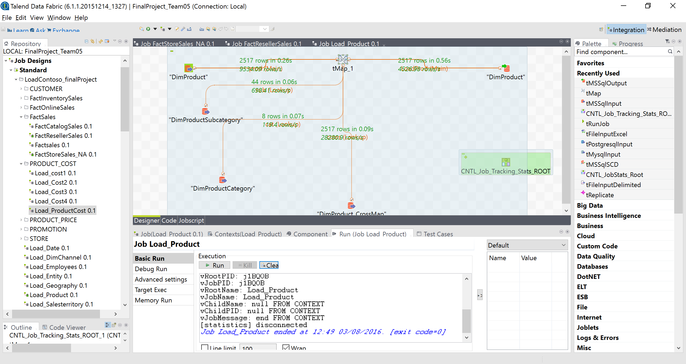

1. DimPromotion

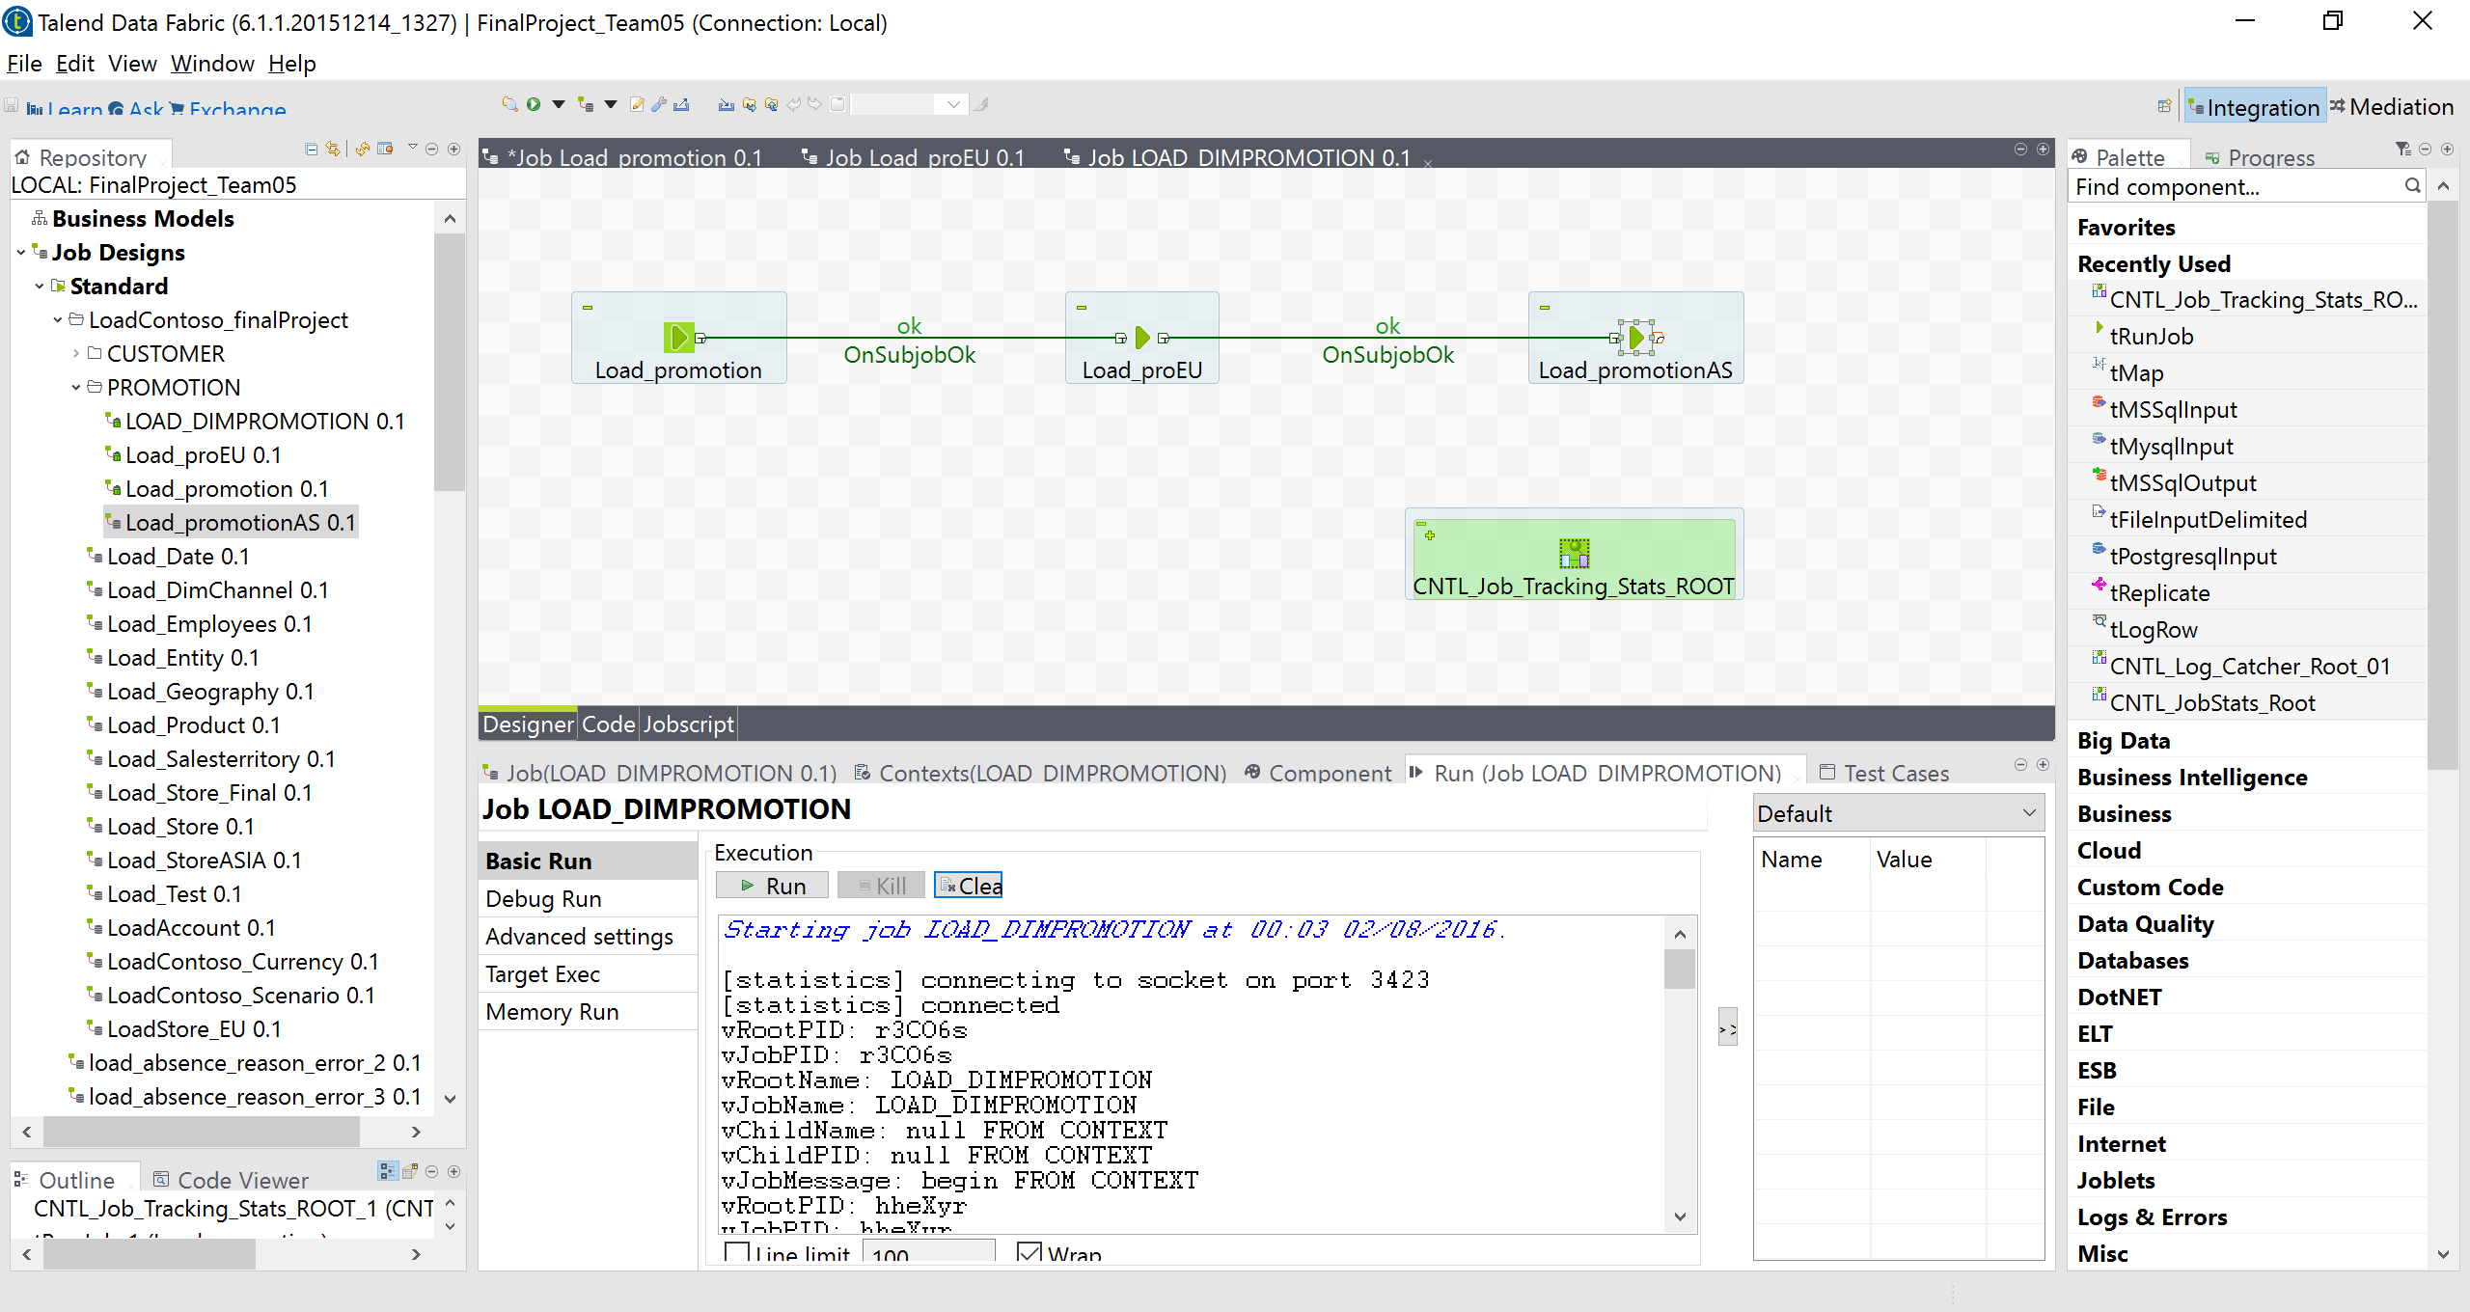

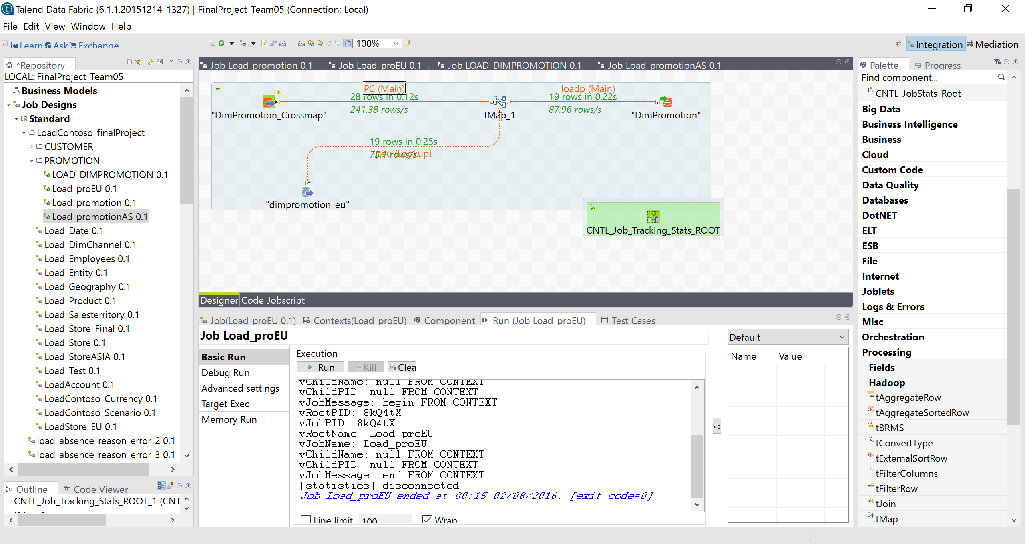

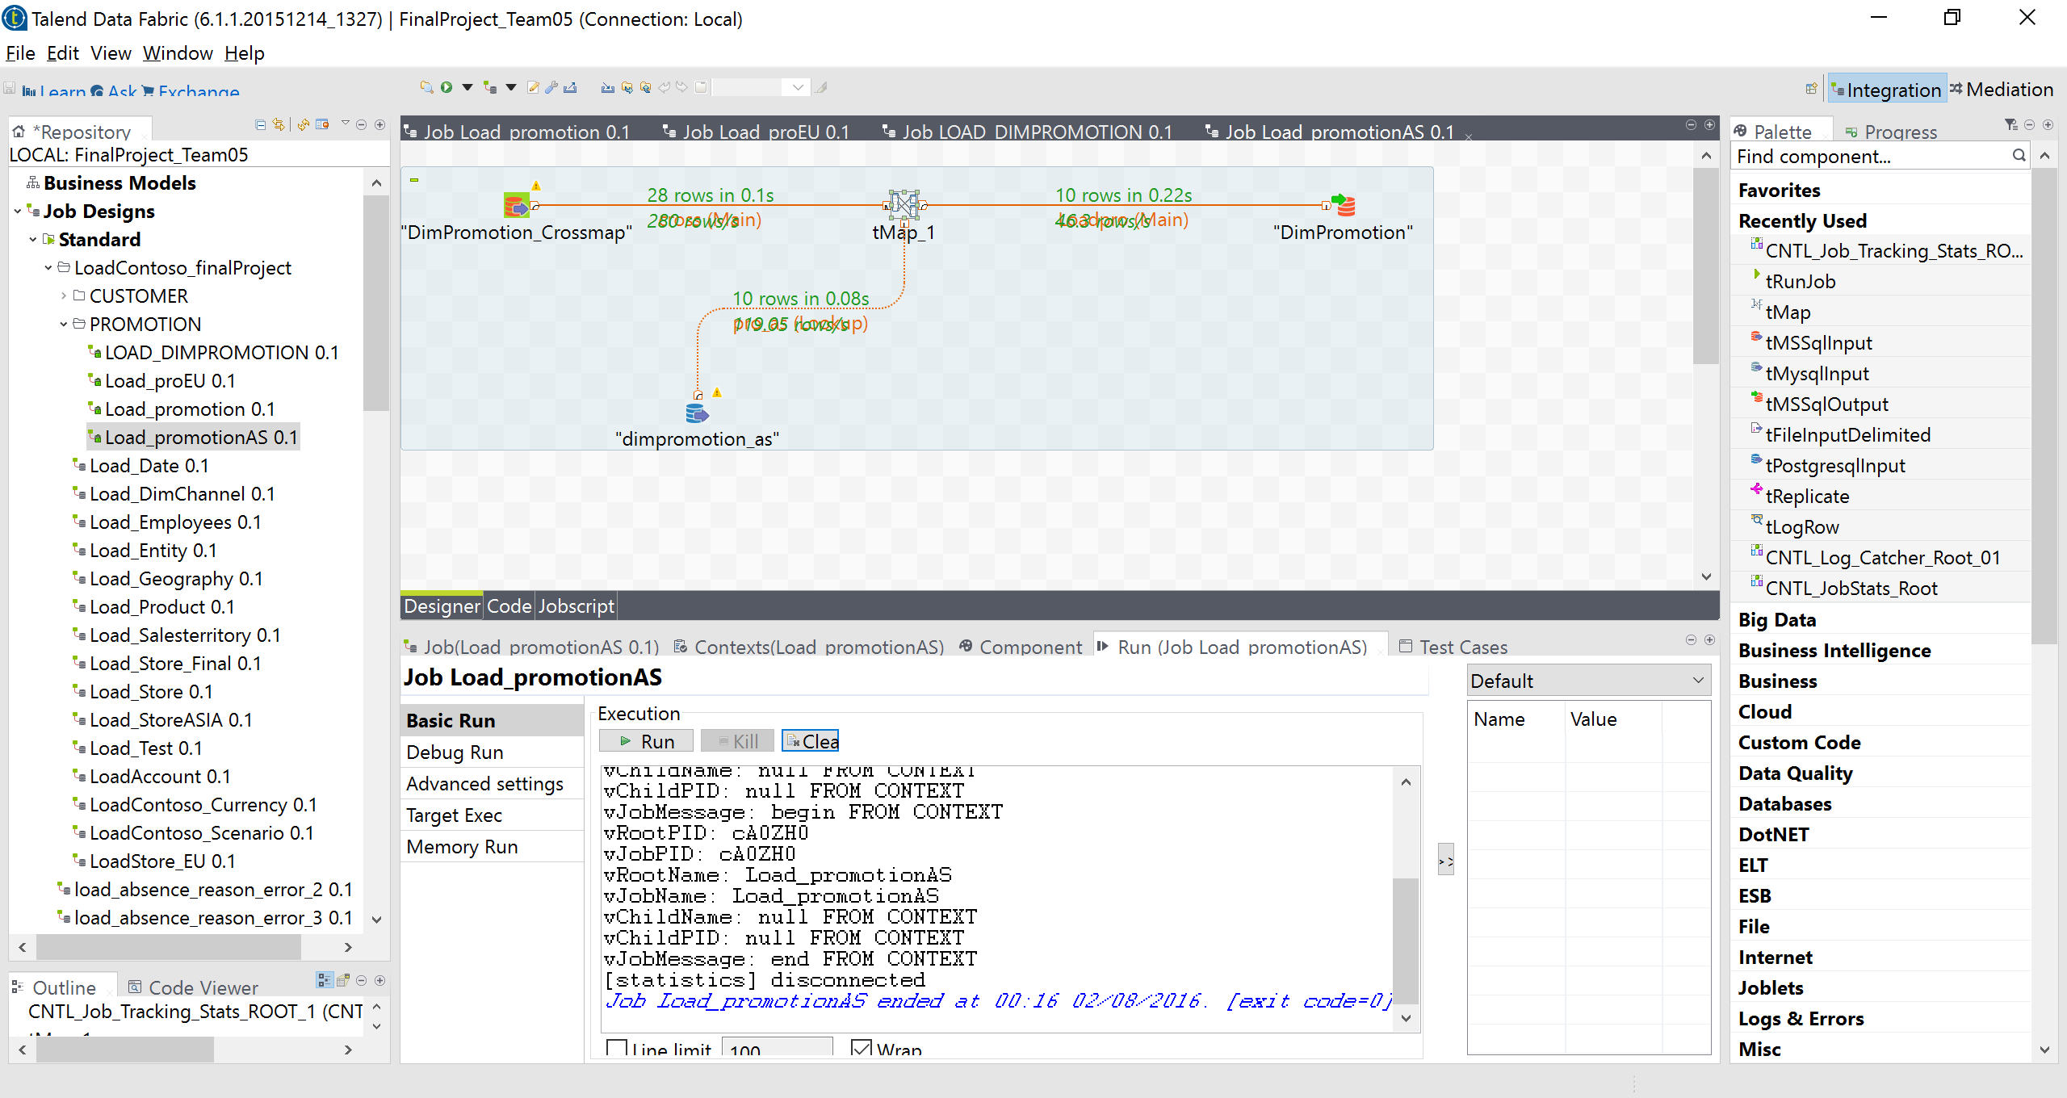

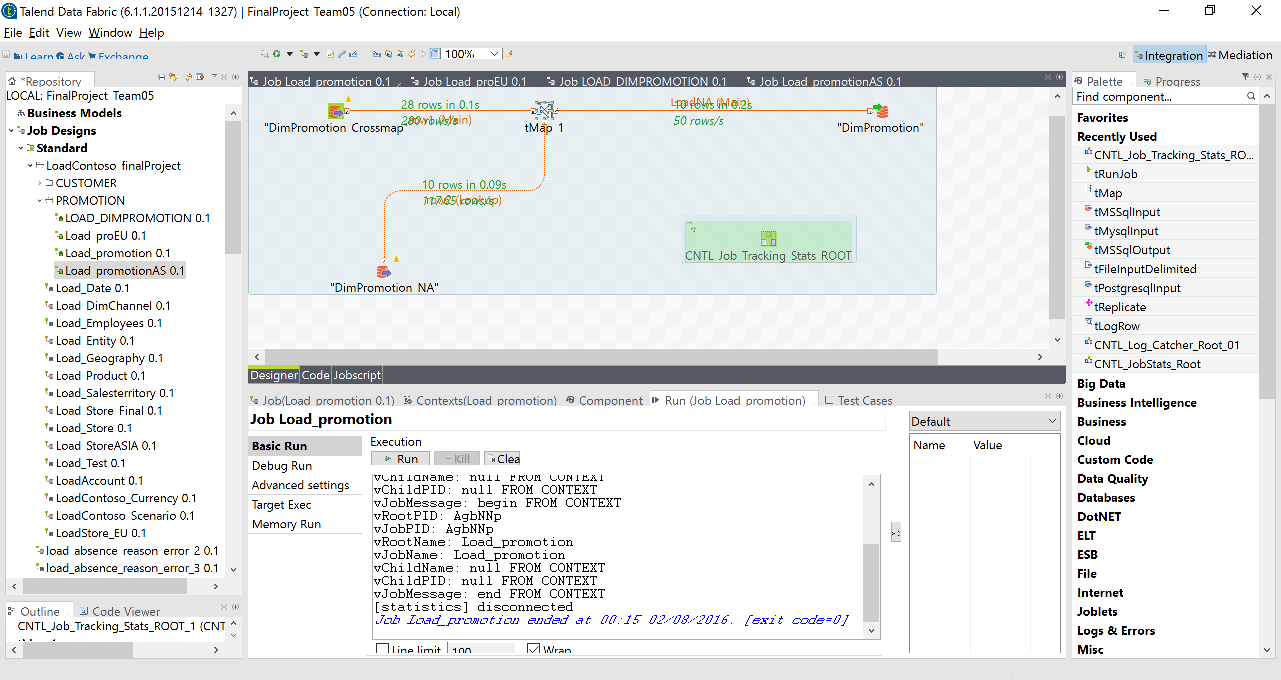

1. DimCustomer

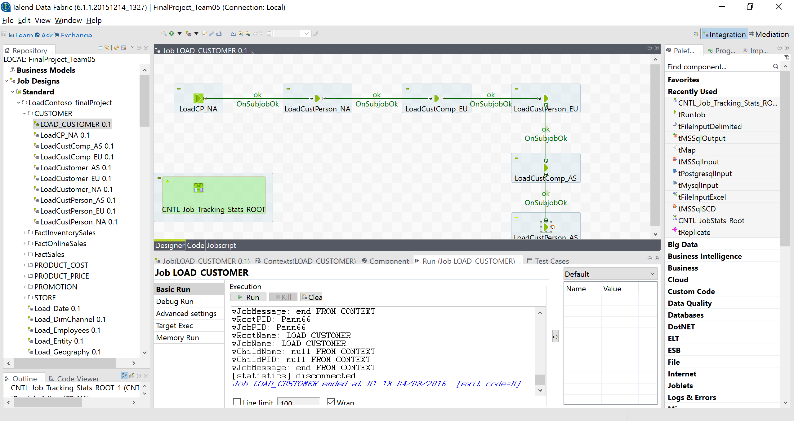

|  |  |  |  |
| --- | --- | --- | --- |
| **Table** | **vRootPID** | **Time** | **Total Rows** |
| DimCurrency | Q14vzF | 0.11s | 28 |
| DimChannel | LAKFC4 | 0.1s | 4 |
| Dimgeography | oDZCYA | 0.66s | 674 |
| DimAccount | Leskju | 0.11s | 24 |
| DimEmployee | 0lkqkc | 02s | 293 |
| Dimproduct | j1BQOB | 0.56s | 2517 |
| DimCustomer | Pann66 |  | 18869 |
| DimPromotion | r3CO6s | 0.22s | 28 |

**FACTONLINESALES**

**Total:** 12627608

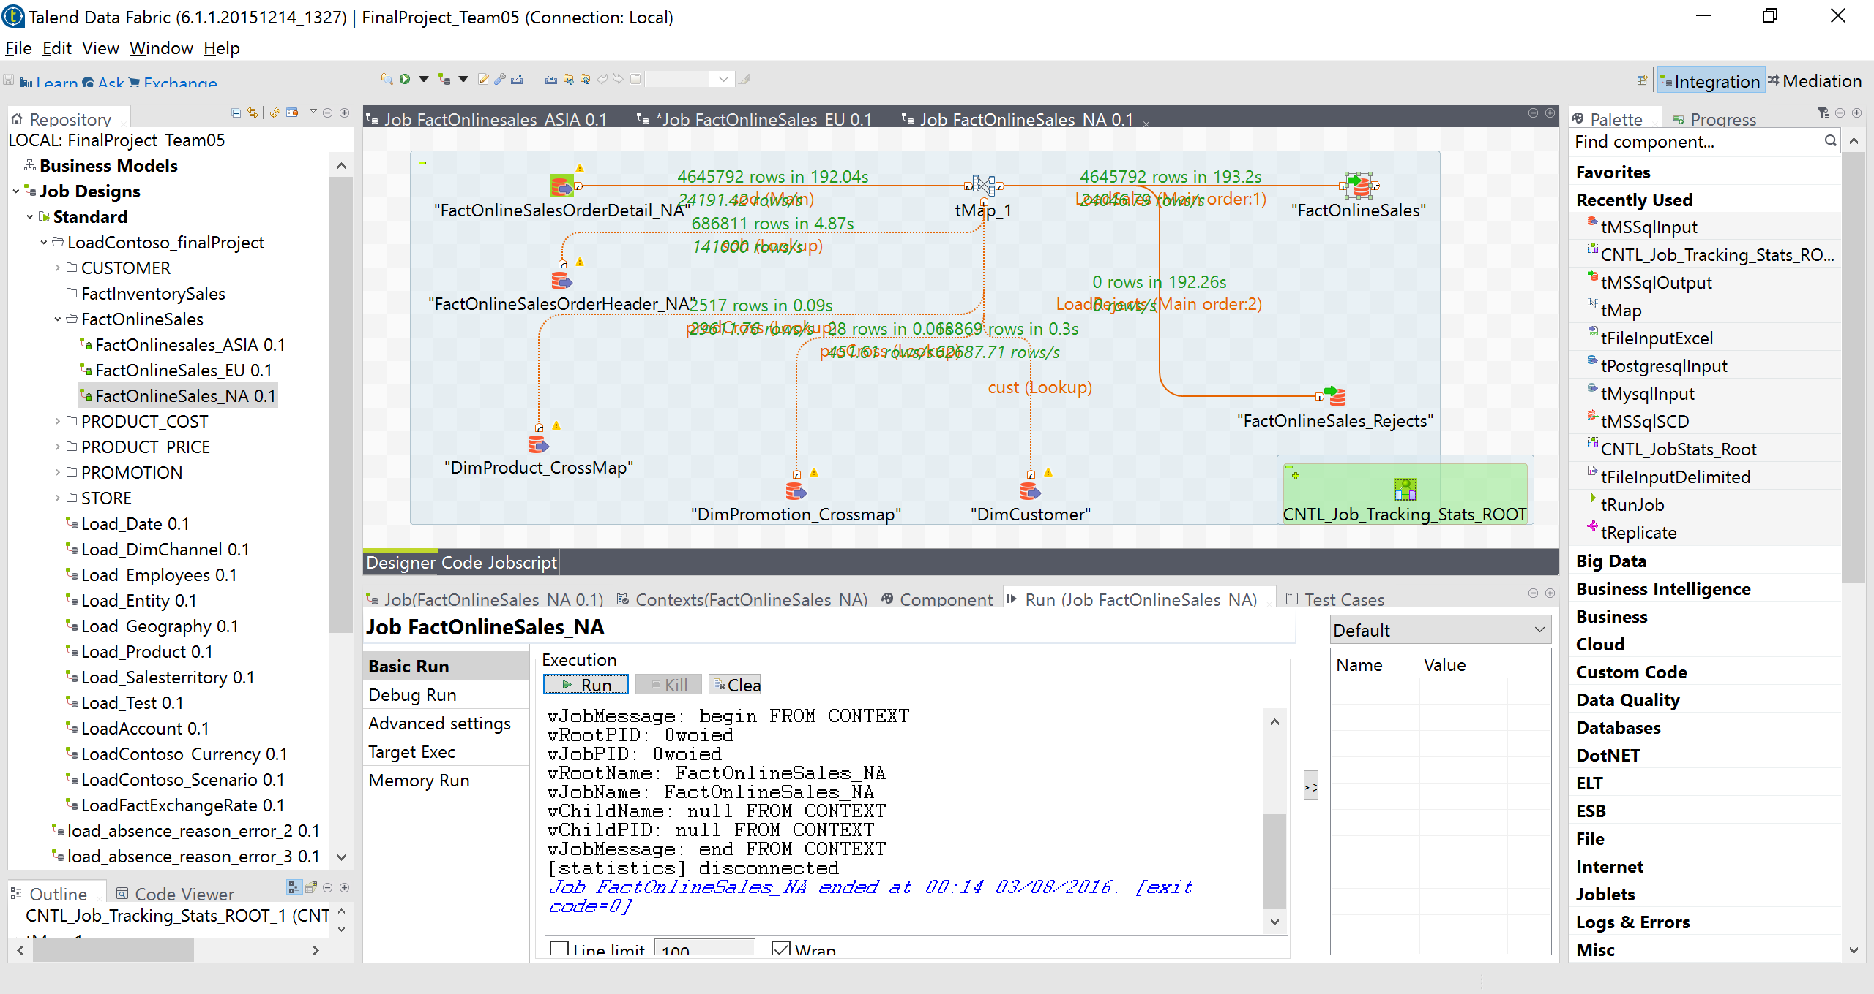

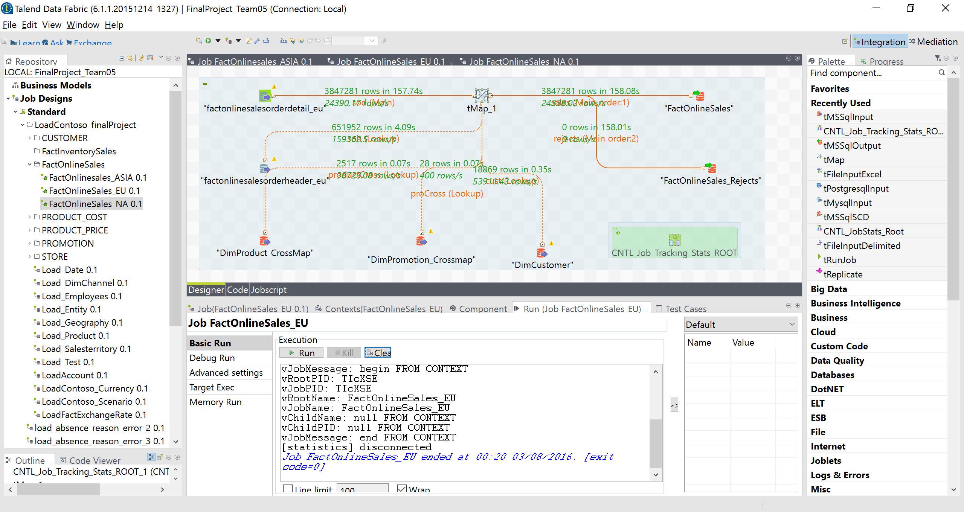

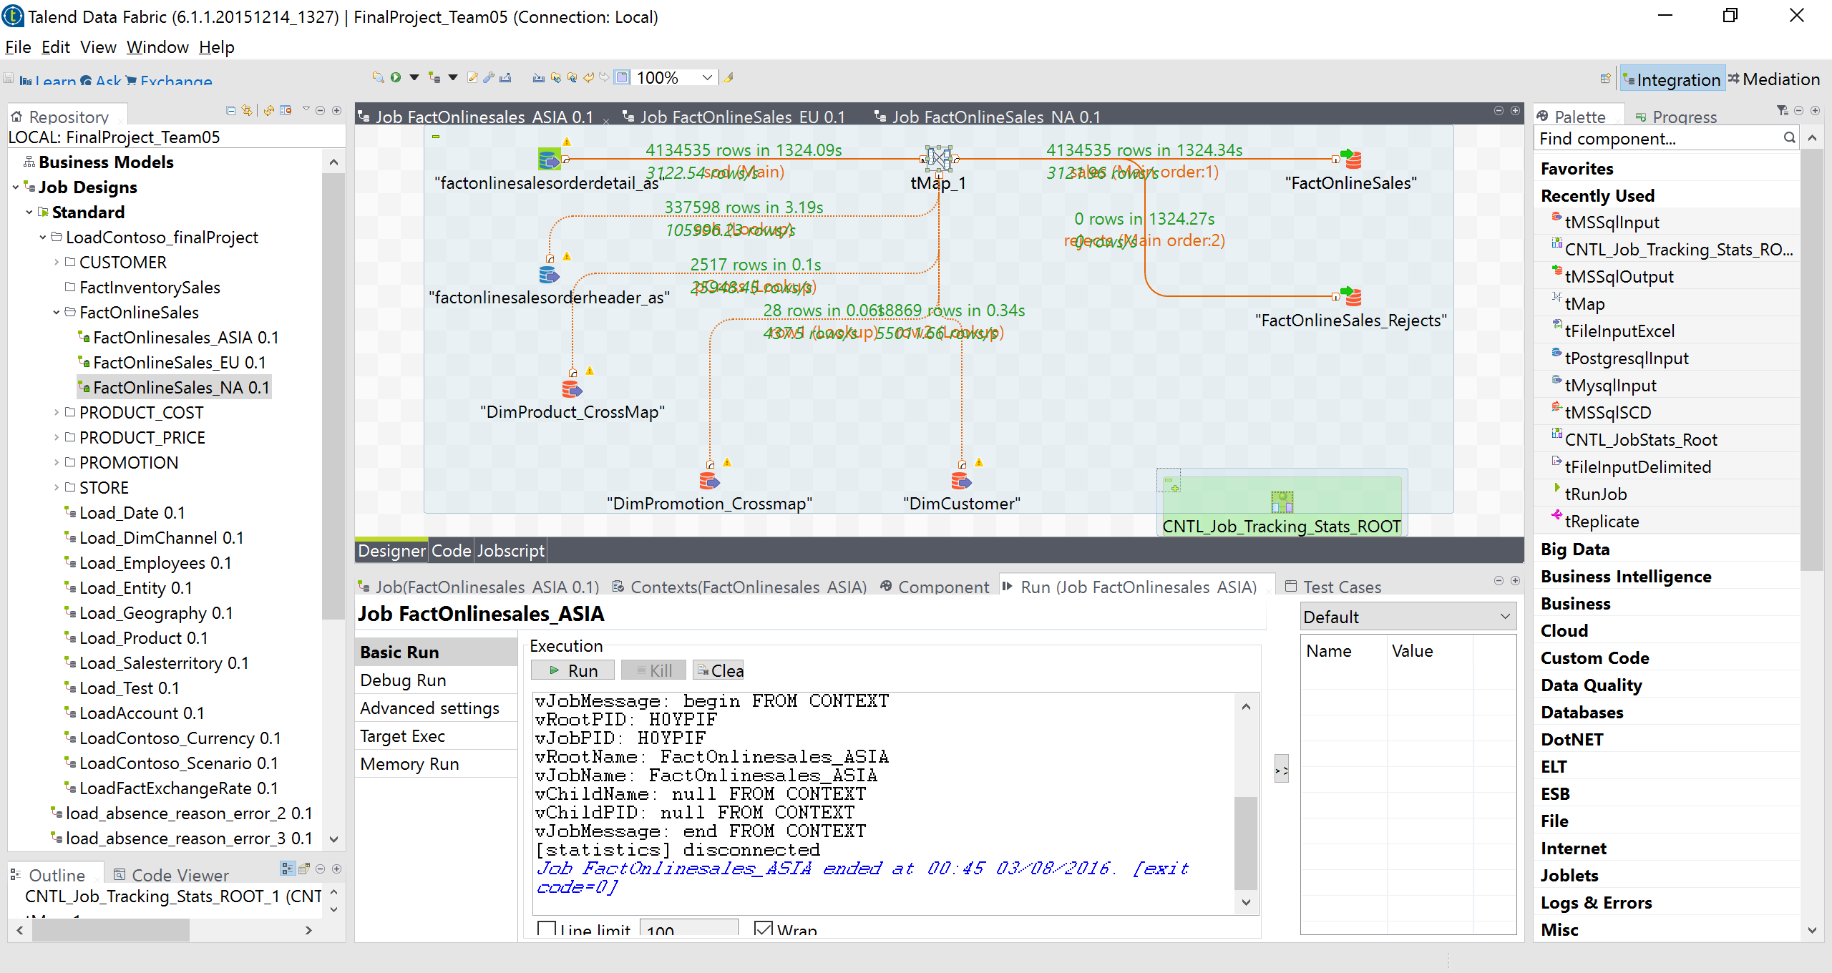

|  |  |  |  |  |  |
| --- | --- | --- | --- | --- | --- |
| **FACTONLINESALES** |  |  |  |  |  |
| **Region** | **Table** | **JobID** | **Time** | **JobTime** | **Rows Count** |
| FactOnlineSales_EU | FactOnlineSales | TIcXSE | Start: 00:17 03/08/2016. | 158.08s | **3847281** |
|  |  |  | End: 00:20 03/08/2016 |  |  |
|  |  |  |  |  |  |
| FactOnlineSales_NA | FactOnlineSales | 0woied | Start: 00:10 03/08/2016 | 193.2s | 4645792 |
|  |  |  | End: 00:14 03/08/2016 |  |  |
|  |  |  |  |  |  |
| FactOnline_ASIA | FactOnlineSales | H0YPIF | Start: 00:22 03/08/2016. |  | 4134535 |
|  |  |  | End: 00:45 03/08/2016 |  |  |
|  |  |  |  |  |  |

**FACTINVENTORYSALES:**

**Total: 8484527**

**Rejects: 217208**

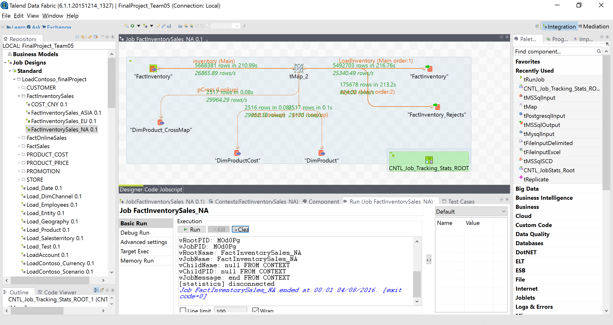

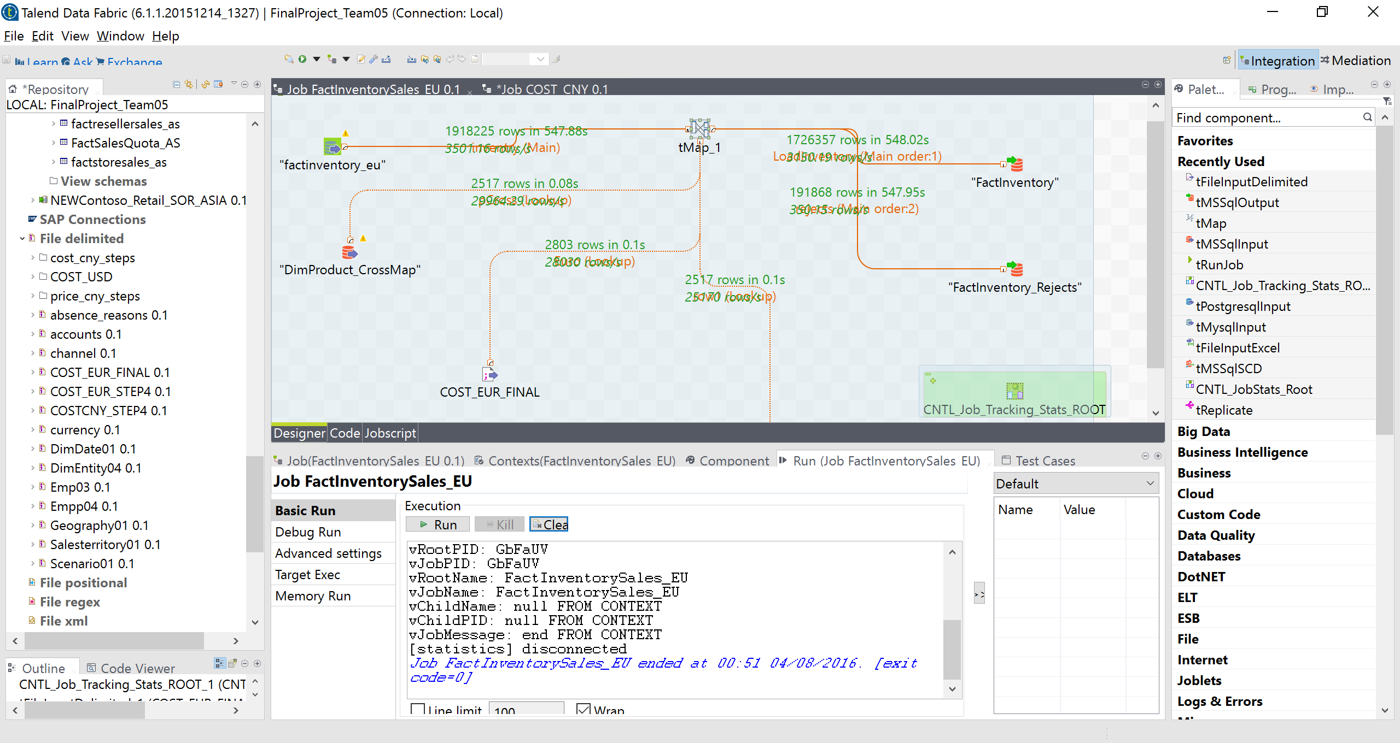

|  |  |  |  |  |  |
| --- | --- | --- | --- | --- | --- |
| **FACTINVENTORYSALES** |  |  |  |  |  |
| **Region** | **Table** | **JobID** | **Time** | **Job RunTime** | **Rows Count** |
| FactInventorySales_EU | FactInventorySales | GbFaUV | Start: 00:42 04/08/2016. | 548.02s | 1726357 |
|  | Rejects |  | End: 00:51 04/08/2016 | 547.95s | 191868 |
|  |  |  |  |  |  |
| FactInventorySales_NA | FactInventorySales | MOd0Pg | Start: 23:58 03/08/2016 | 216.76s | 5492703 |
|  | Rejects |  | End: 00:01 04/08/2016. | 213.2s | 175678 |
|  |  |  |  |  |  |
| FactInventory_ASIA | FactInventorySales | cKOm8F | Start: 01:01 04/08/2016. | 432.69s | 1235467 |
|  | Rejects |  | End: 01:08 04/08/2016 | 432.63s | 0 |
|  |  |  |  |  |  |

**FACTSALES: ----NA----**

**Total:**

**FactSales: 10776123**

**factSales_rejects : 604234**

1. **CatalogSales:**

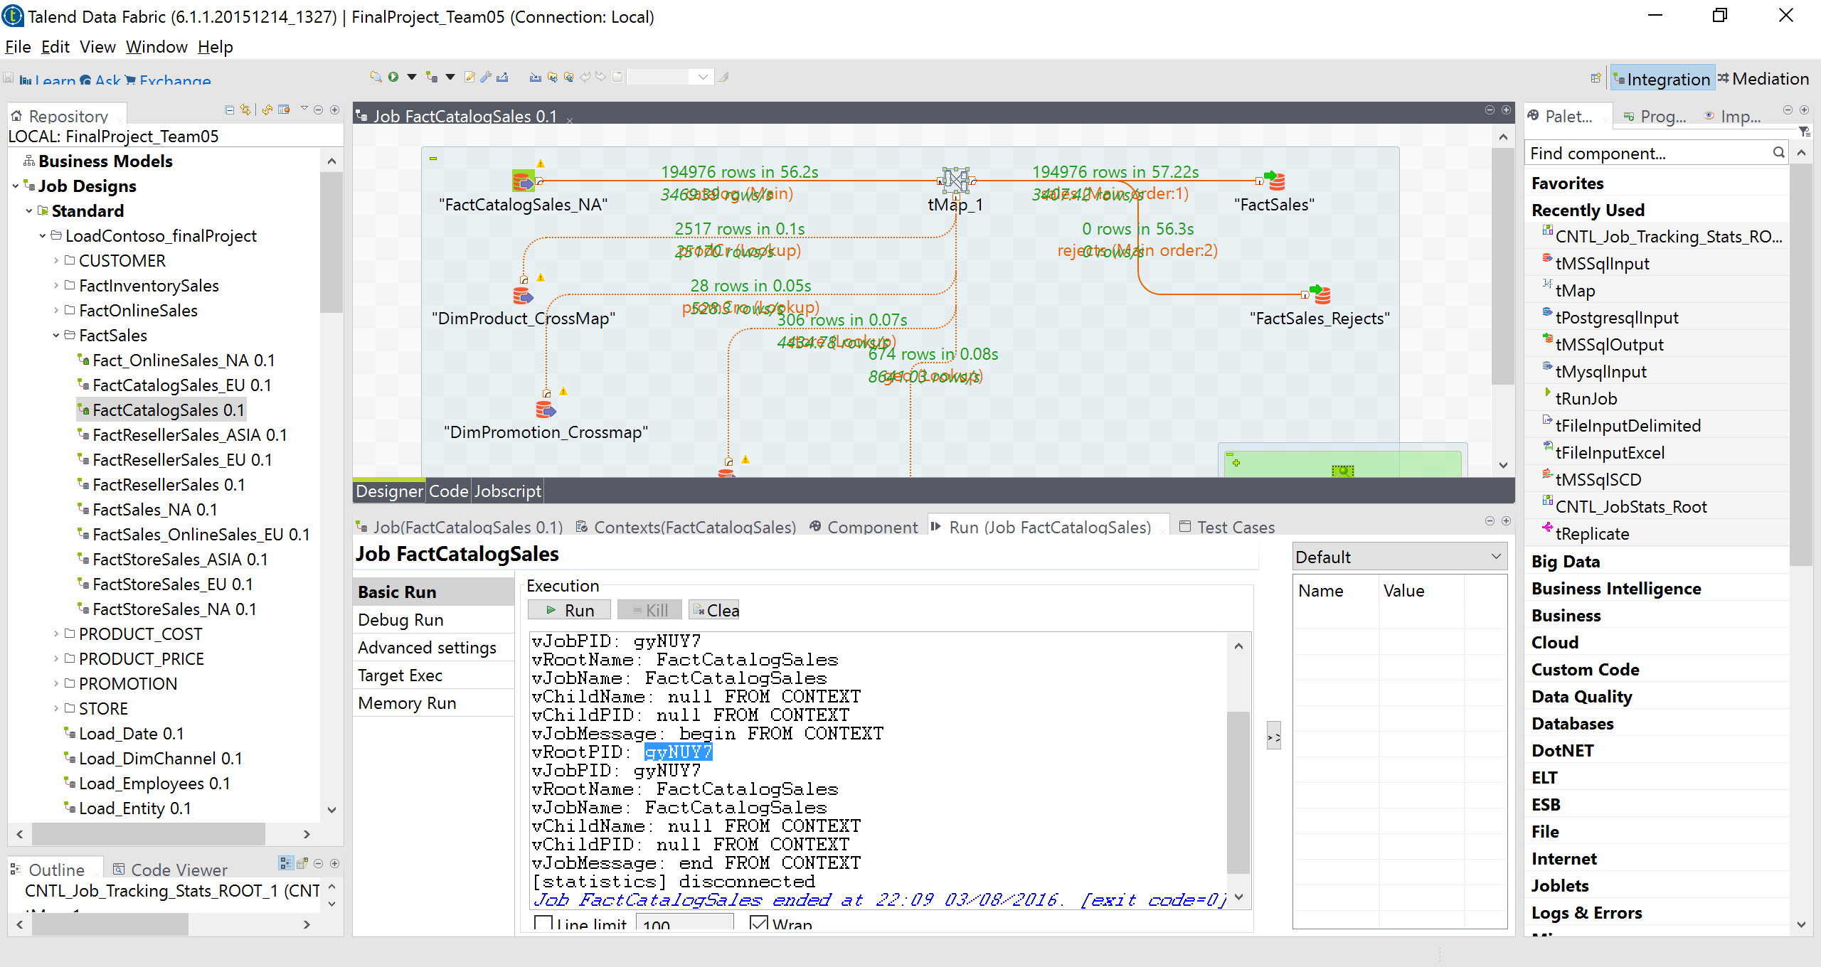

1. **Reseller Sales:**

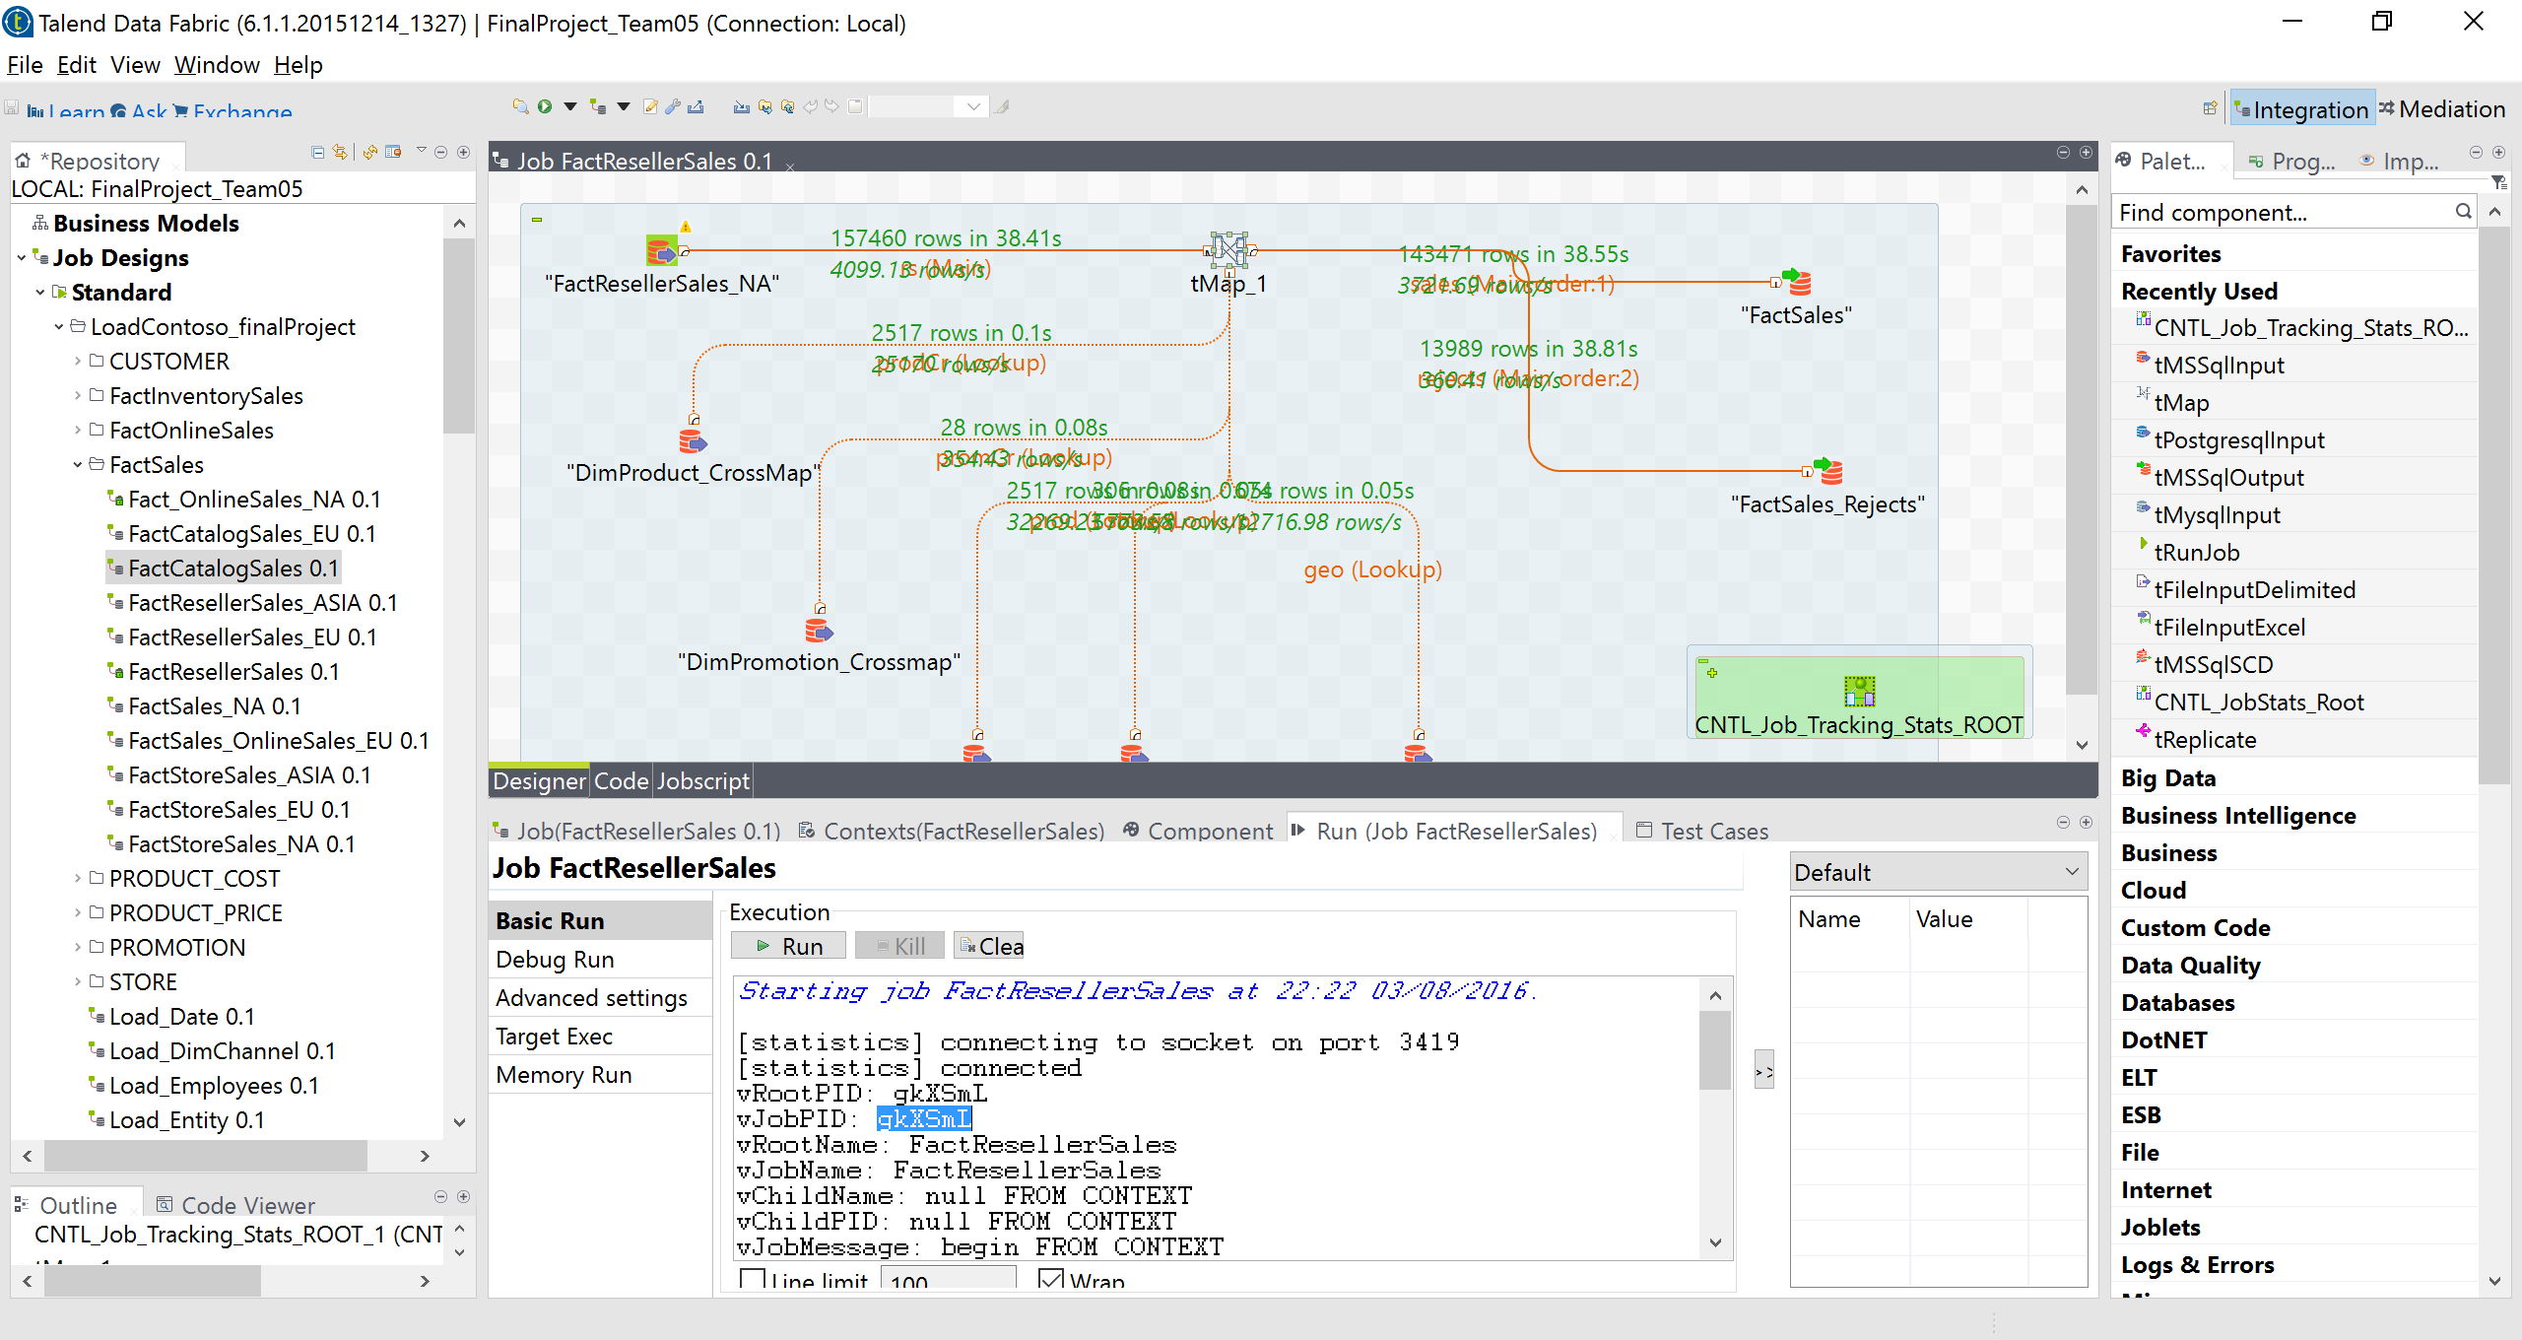

1. **StoreSales:**

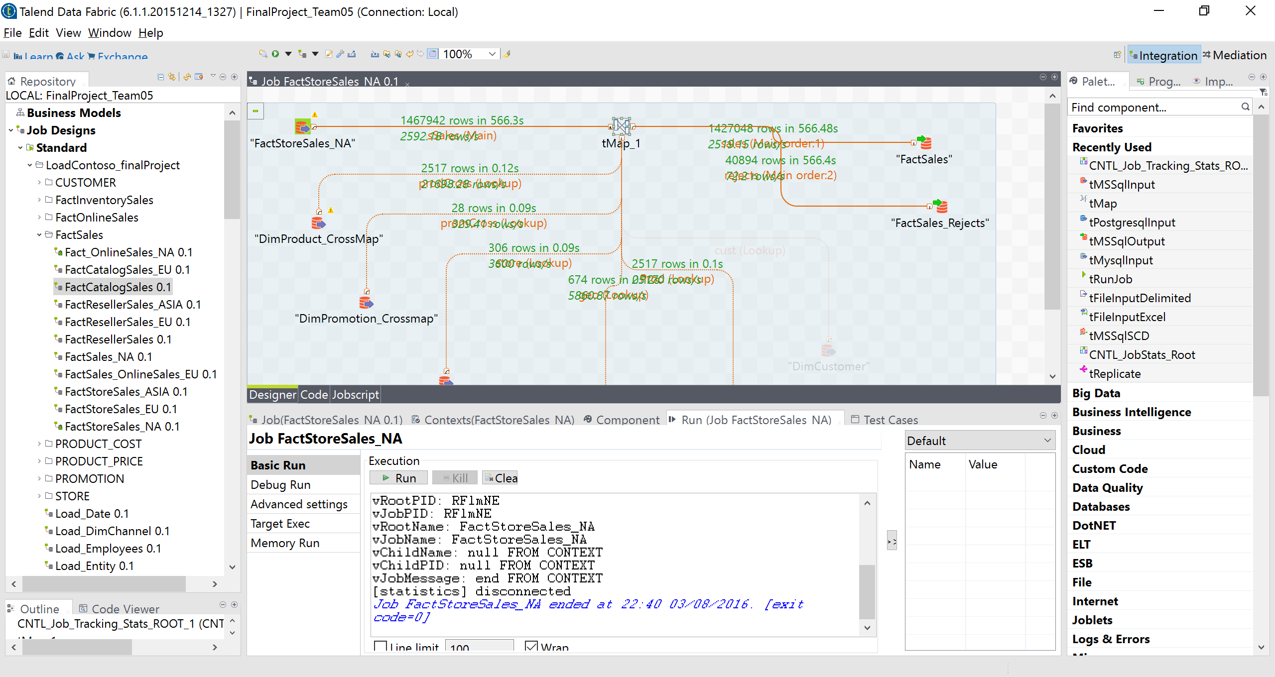

1. **Onlinesales**

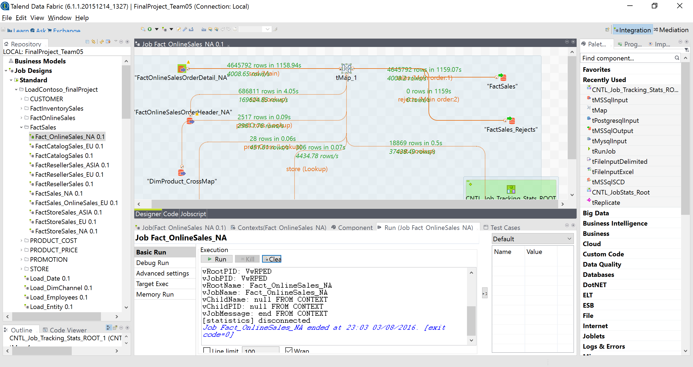

|  |  |  |  |  |
| --- | --- | --- | --- | --- |
| **FACTSALES** |  |  |  |  |
| **NA** |  |  |  |  |
| **Channel** | **Table** | JobID | Time | Rows Count |
| Catelog | Factsales | Ue4Lzy | 49.82s | 194976s |
|  | Factsales_rejects | Ue4Lzy | 49.75s | 0 |
|  |  |  |  |  |
| Reseller | Factsales | gkXSmL | 38.85s | 143471 |
|  | Factsales_rejects | gkXSmL | 38.81s | 13989 |
|  |  |  |  |  |
| storeSales | Factsales | RFlmNE | 375.65s | 1427048 |
|  | Factsales_rejects |  | 375.58s | 40894 |
|  |  |  |  |  |
| Online | Factsales | VwRPED | 1156.07s | 4645792s |
|  | Factsales_rejects | VwRPED | 1156s | 0 |

**----EU----**

1. **ResellerSales:**

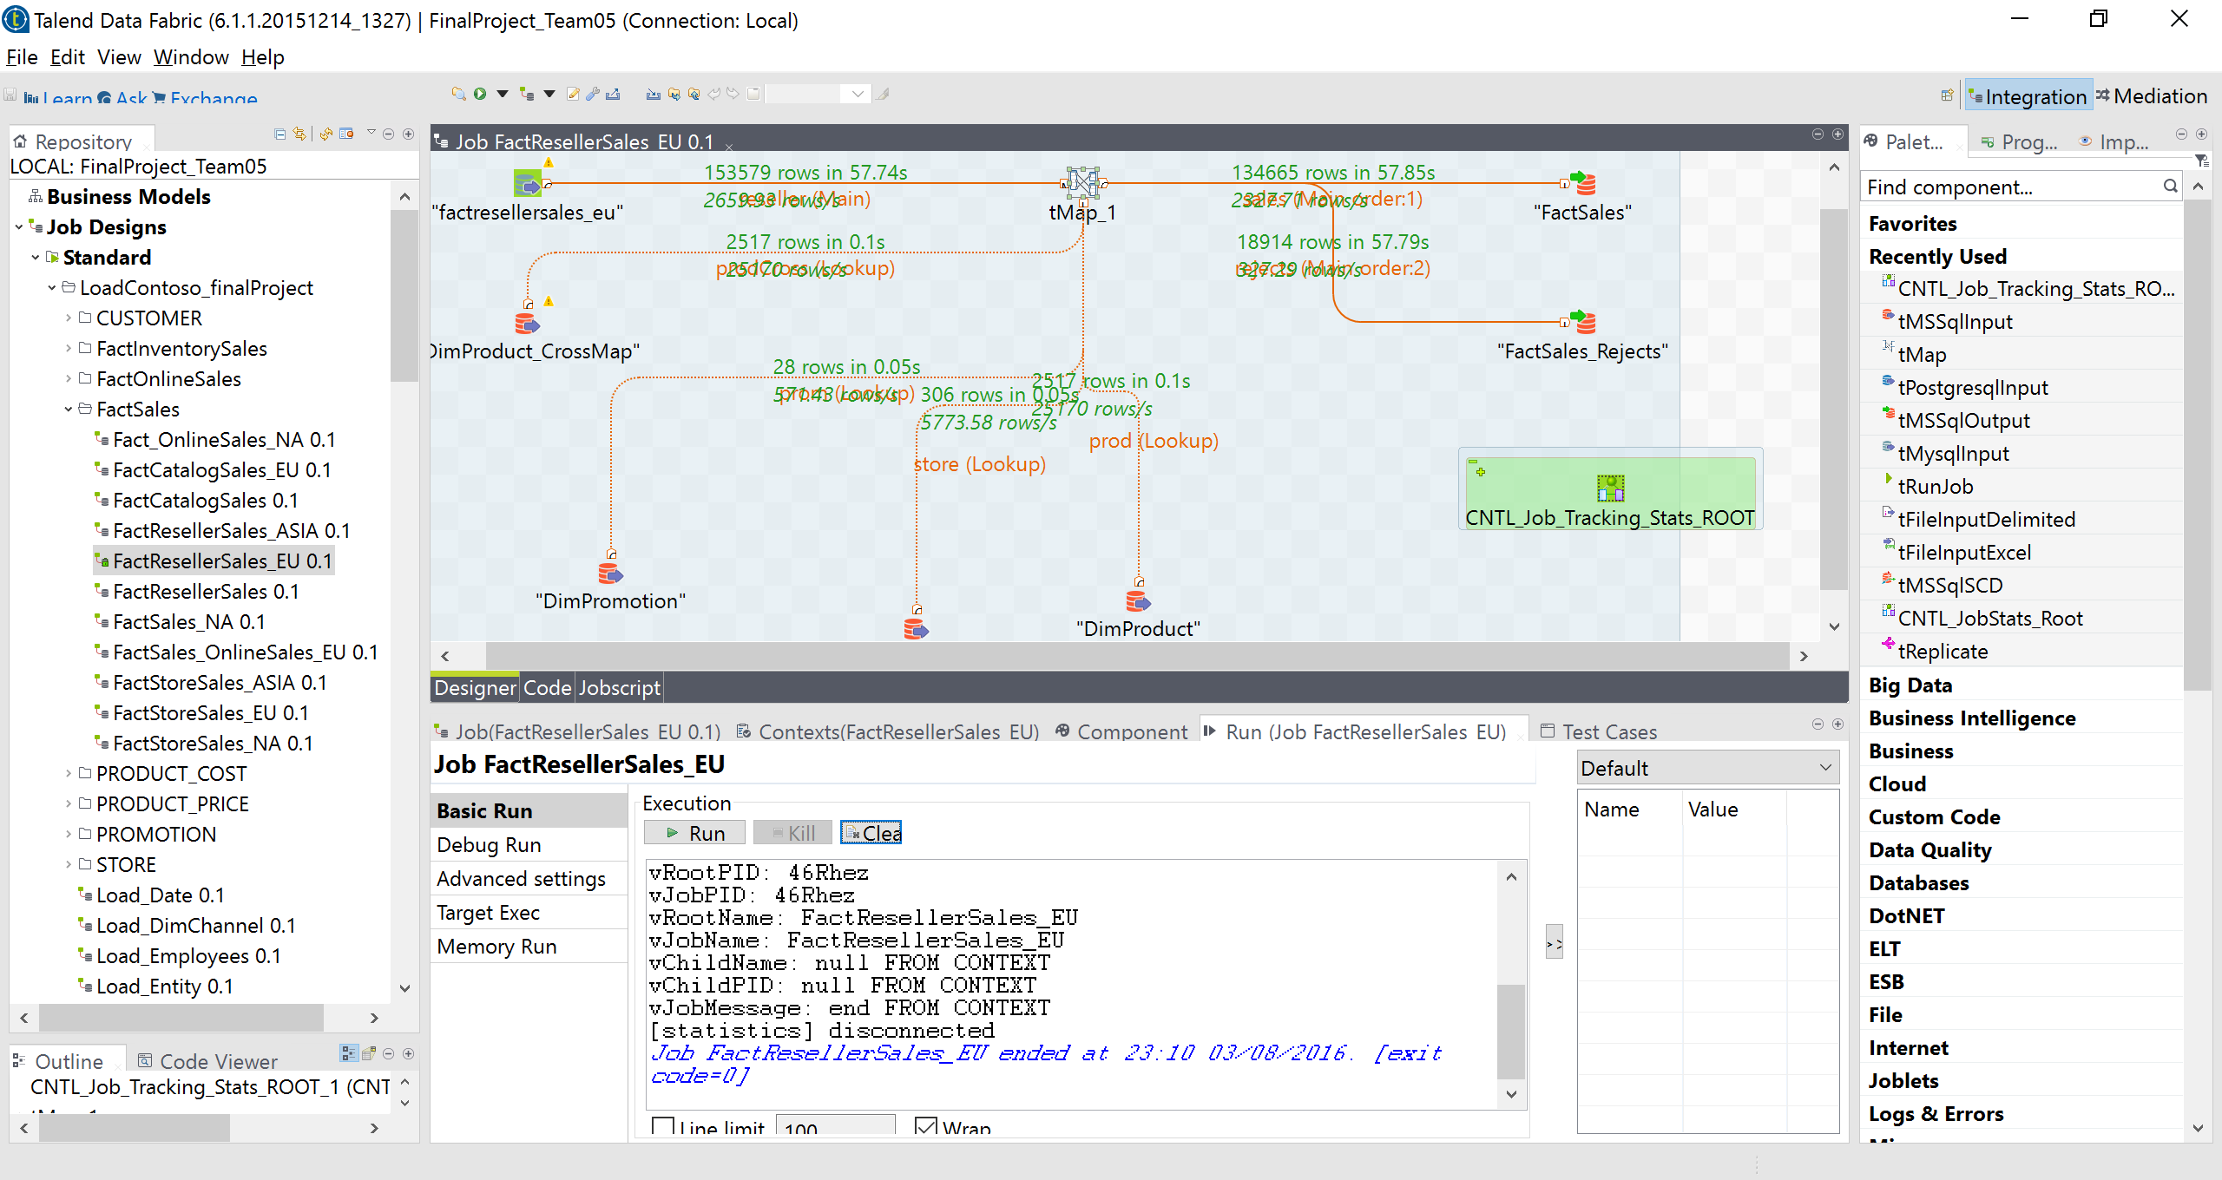

1. **StoreSales:**

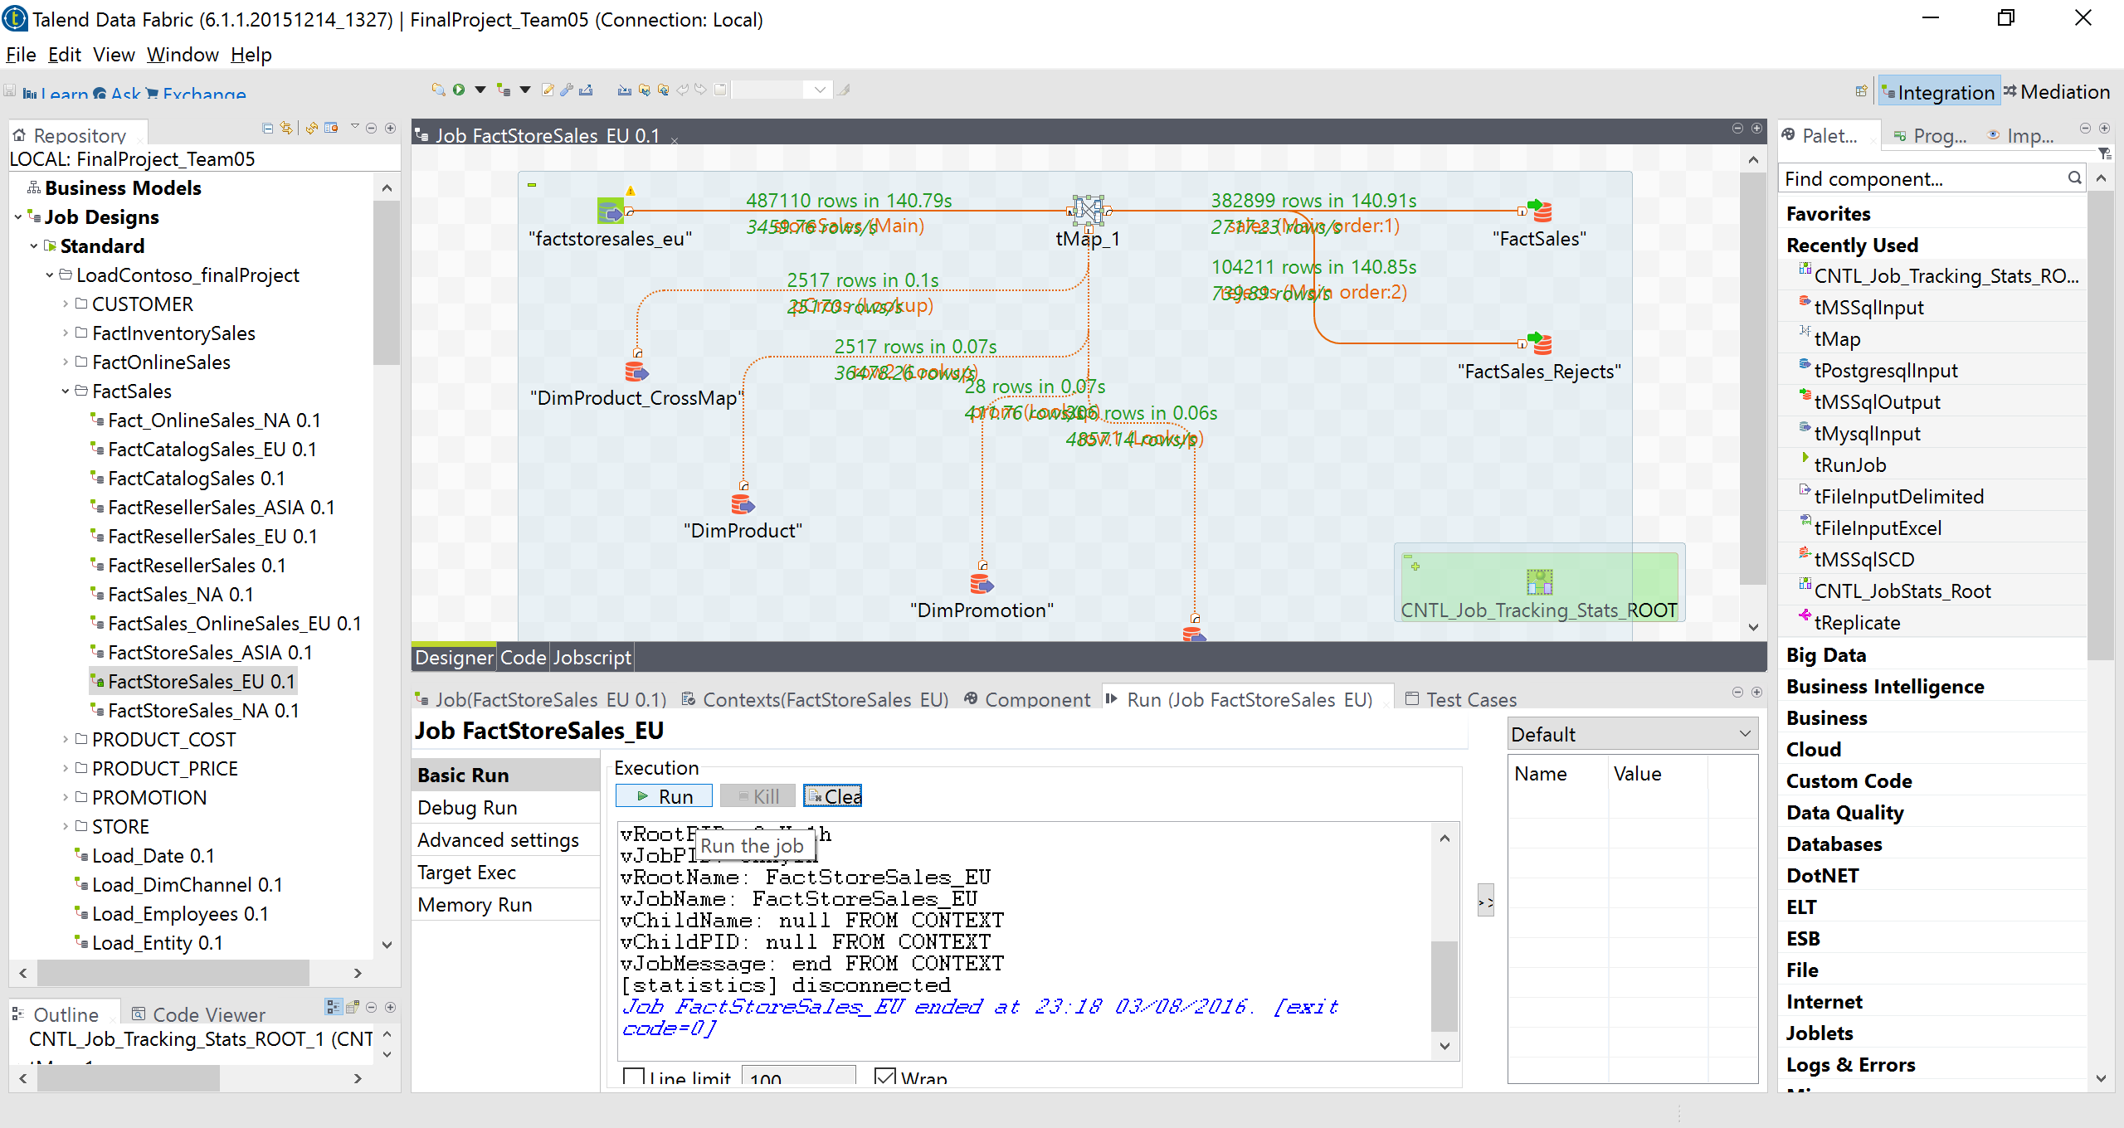

1. **OnlineSales:**

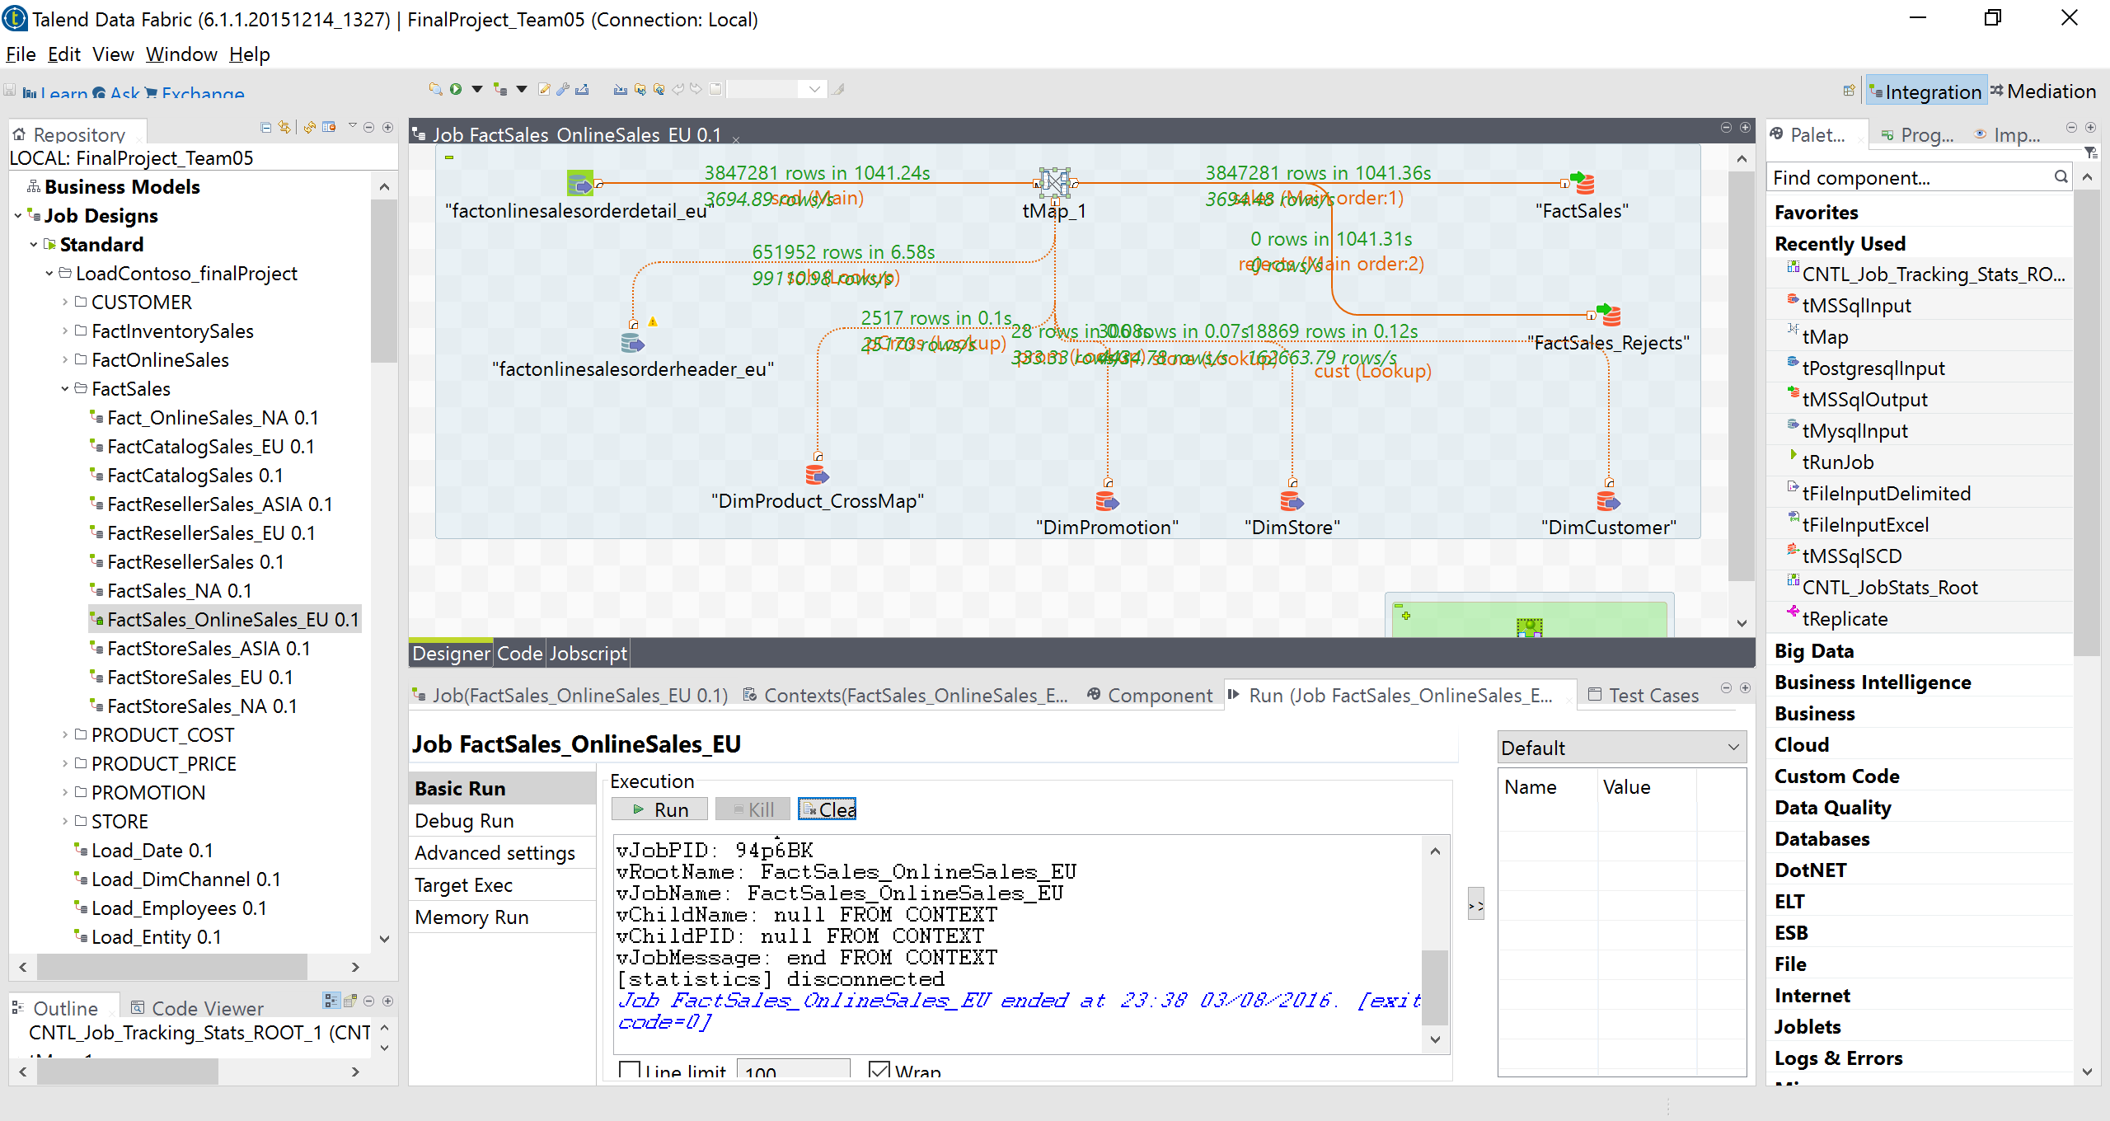

|  |  |  |  |  |
| --- | --- | --- | --- | --- |
| **EU** |  |  |  |  |
| **Channel** | **Table** | **JobID** | **Time** | **Rows Count** |
| Reseller | Factsales | 46Rhez | 57.85s | 134665 |
|  | Factsales_rejects |  | 57.79s | 18914 |
|  |  |  |  |  |
| Store | Factsales | 3nHy1h | 140.91.s | 383899 |
|  | Factsales_rejects | 3nHy1h | 140.85s | 104211 |
|  |  |  |  |  |
| Onlinesales | Factsales | 94p6BK | 1041.36s | 3847281 |
|  | Factsales_rejects |  | 1041.31s | 0 |
|  |  |  |  |  |

**---ASIA---**

1. **ResellerSales**

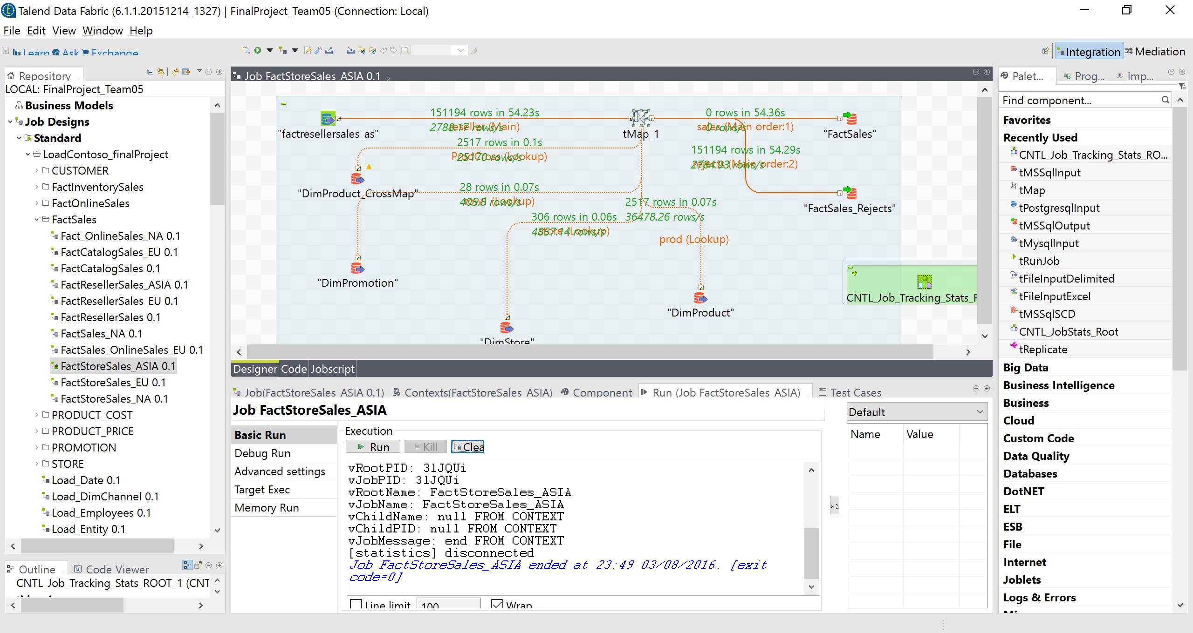

**2.StoreSales**

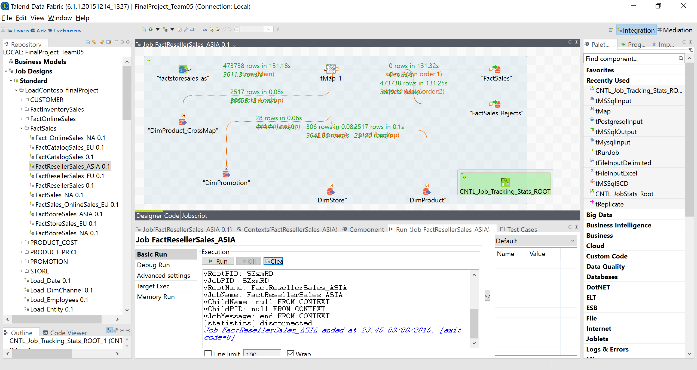

|  |  |  |  |  |
| --- | --- | --- | --- | --- |
| **ASIA** |  |  |  |  |
| **Channel** | **Table** | **JobID** | **Time** | **Rows Count** |
| Reseller | Factsales | SZxmRD | 131.32s | 0 |
|  | Factsales_rejects |  | 131.25s | 473738 |
|  |  |  |  |  |
| StoreSales | Factsales | 3lJQUi | 54.36s | 0 |
|  | Factsales_rejects |  | 54.29s | 151194 |
|  |  |  |  |  |